



**RESTURANT MANAGEMENT SYSTEM**

**6TH Semester Diploma in Computer Engg.**

**Submitted By: Nitika (36)**

**Submitted To: Ms. Payal Mam**

**Branch: Computer Engg.**

# 

# A PROJECT REPORT

**ON**

**“Restaurant Management System ”**

SUBMITTED IN PARTIAL FULFILLMENT OF THE REQUIREMENTS FOR THE AWARD OF

**DIPLOMA IN**

**Computer Engineering**

**SUBMITTED TO**

**HARYANA STATE BOARD OF TECHNICAL EDUCATION, HARYANA**

**PANCHKULA**

# SUBMITTED BY :

# Nitika 200010800036

# Chirag Kapoor 200010800016

# Lakshay Dhiman 200010800033

# Nikhil Saini 200010800035

# Karan Sharma 200010800029

# GUIDED BY : Ms. Payal mam



**GOVT. POLYTECHNIC, AMBALA CITY**

**ACADEMIC YEAR**

**2020-2023**



**GOVT. POLYTECHNIC AMBALA CITY**

# CERTIFICATE

**This is to Certify that the project report entitled “Restaurant Management System” Was successfully completed by Student of 6th semester Diploma in computer engineering.**

1. Nitika
2. Chirag Kapoor
3. Lakshay Dhiman
4. Nikhil Saini
5. Karan Sharma

**in partial fulfillment of the requirements for the award of the Diploma in Computer engineering and submitted to the Department of computer engineering of Govt. Polytechnic, Ambala City work carried out during a period for the academic year**

**2020-2023 as per curriculum .**

Name of Guide: Name of HOD:

Ms. Payal Mr. Munish Gupta

External Examiner Principal

Dr. Rajeev Sapra

ACKNOWLEDGMENT

This project is done as a semester project, as a part course titled

**“Restaurant Management System”** We are really thankful to our course the Principal **Dr. Rajeev sapra** and the **HOD Mr. Munish Gputa** ,**computer engineering**, Govt. Polytechnic Ambala City, Ambala for his invaluable guidance and assistance, without which the accomplishment of the task would have never been possible.

We also thank **Govt. polytechnic Ambala city** for giving this opportunity t o explore into the real world and realize the interrelation without which a Project can never progress. In our present project we have chosen the topic- **“Restaurant Management system ”.**

We are also thankful to parents, friend and all staff of **computer engineering** for providing us relevant information and necessary clarifications, and great support.

[**Restaurant management system project in Python**](https://copyassignment.com/restaurant-management-system-project-in-python/)

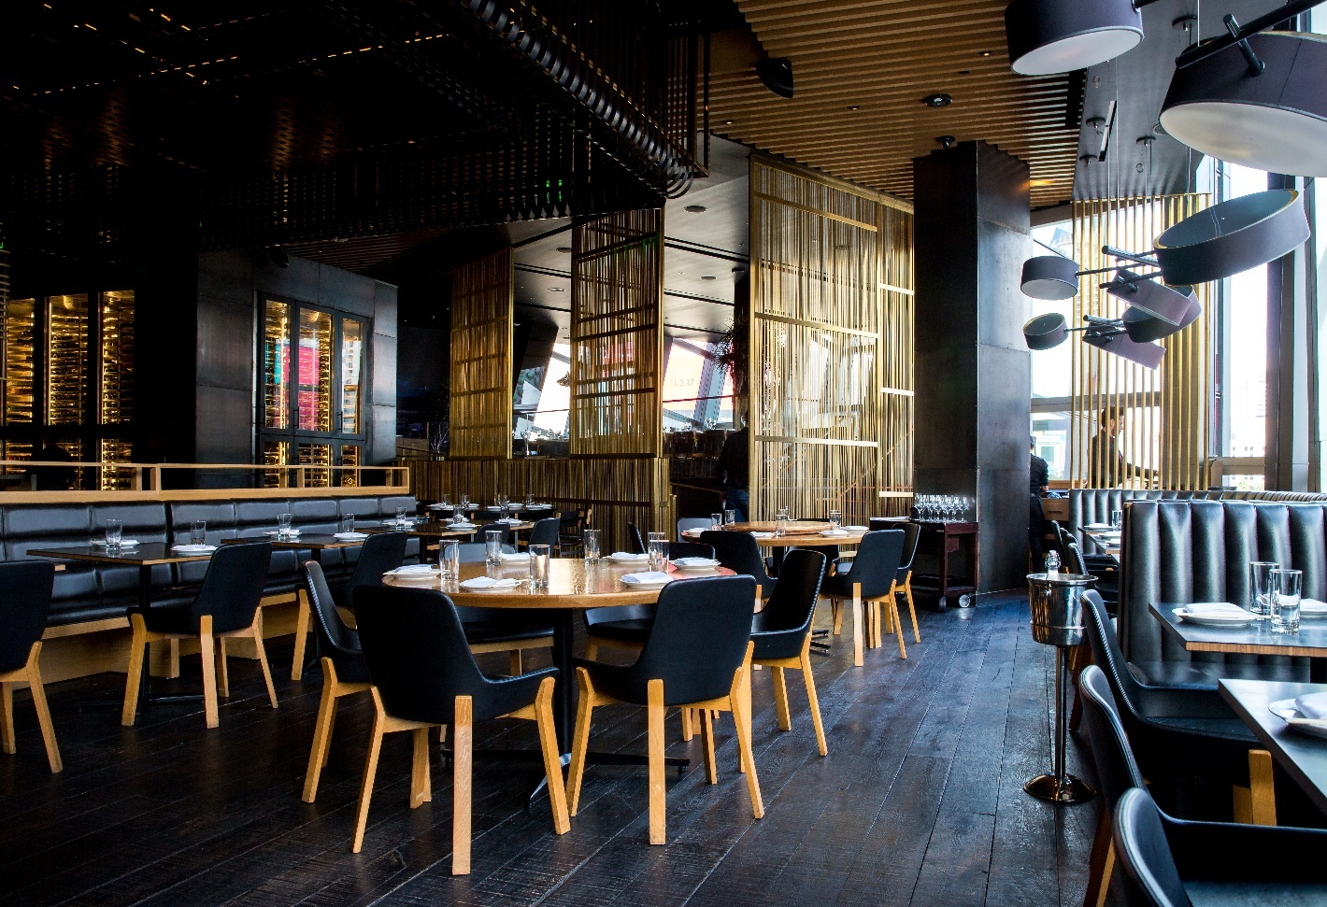

**About Restaurant Management System Project in Python:-**

In the **Restaurant management system project in Python**, we will be having a **GUI**using which we will be able to do complete billing for any customer. Like we will be able to add items and their price to the bill and also calculate their total price using the total button. Also, the data can be stored in our text file.

The first step in building the project is to define the scope and requirements of the system. This can be done by analyzing the current processes and identifying areas that can be improved. The next step is to design the system architecture and database schema. This involves

identifying the entities and relationships involved in the system and creating a data model that can store and manage the data.

After designing the system, the next step is to develop the system components. This involves writing the code for various modules such as user interface, database access, business logic, etc. The code should be modular and well-organized, following best practices for software development.

Once the development is complete, the system should be tested thoroughly to ensure that it meets the requirements and functions as expected. Any bugs or issues should be identified and fixed before deploying the system.

Overall, a Restaurant Management System Project in Python can be a challenging and rewarding project for developers. It requires a good understanding of software development principles and the ability to design and implement complex systems. However, with the right approach and tools, it can be a highly valuable system for restaurant owners to streamline their operations and improve their business performance

**Project overview**:- **Restaurant management system project in Python**

|  |  |
| --- | --- |
| **Project Name:** | **Restaurant management system project in Python** |
| **Abstract:** | This is a straightforward **GUI-based program** that is simple to grasp and utilize. The GUI is created with the **Tkinter**package. |
| **Language:** | Python, Tkinter, |
| **IDE** | Pycharm(Recommended) |
| **Python version (Recommended):** | 3.10 |
| **Type/Category:** | Final Year Project using Python |

### **Features and Benefits:-**

* Fill in the order the customer wants
* Complete bill management
* Add tax and services
* Calculate the total in 1 click
* Reset the data

### **Use of Pycharm IDE for Project creation of Restaurant Billing System Project in python:-**

* First Instal pycharm community addition (community edition is to be installed)
* Create New Project and enter “Create

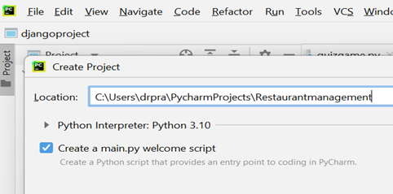

* Right-click on the project name you have created and  Create a New Python File as restaurantmange.py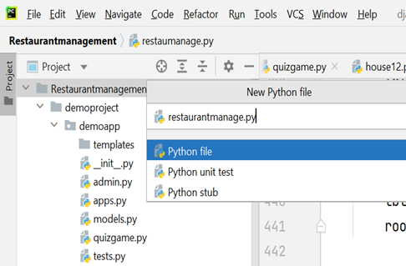

Once you create the python file, write the entire code which includes all the modules for restaurant management.

* Execute the Python Program

**Code flow:**

### **Import the modules required for the project**

**from** tkinter **import** *  
**import** random  
**import** time  
**from** tkinter **import** filedialog,messagebox

**First we create front end side of our project :-**

**First we create GUI**

**from** tkinter **import** *  
**import** random  
**import** time  
**from** tkinter **import** filedialog,messagebox  
  
root=Tk()  
root.geometry(**'1485x750+0+0'**)  
root.resizable(0,0)  
root.config(bg=**'grey20'**)  
root.title(**"restaurant managment system"**)  
root.iconbitmap(**'restaurant.ico'**)  
topframe=Frame(root,bd=10,relief=RIDGE,bg=**'grey11'**)  
topframe.pack(side=TOP)  
  
root.mainloop()

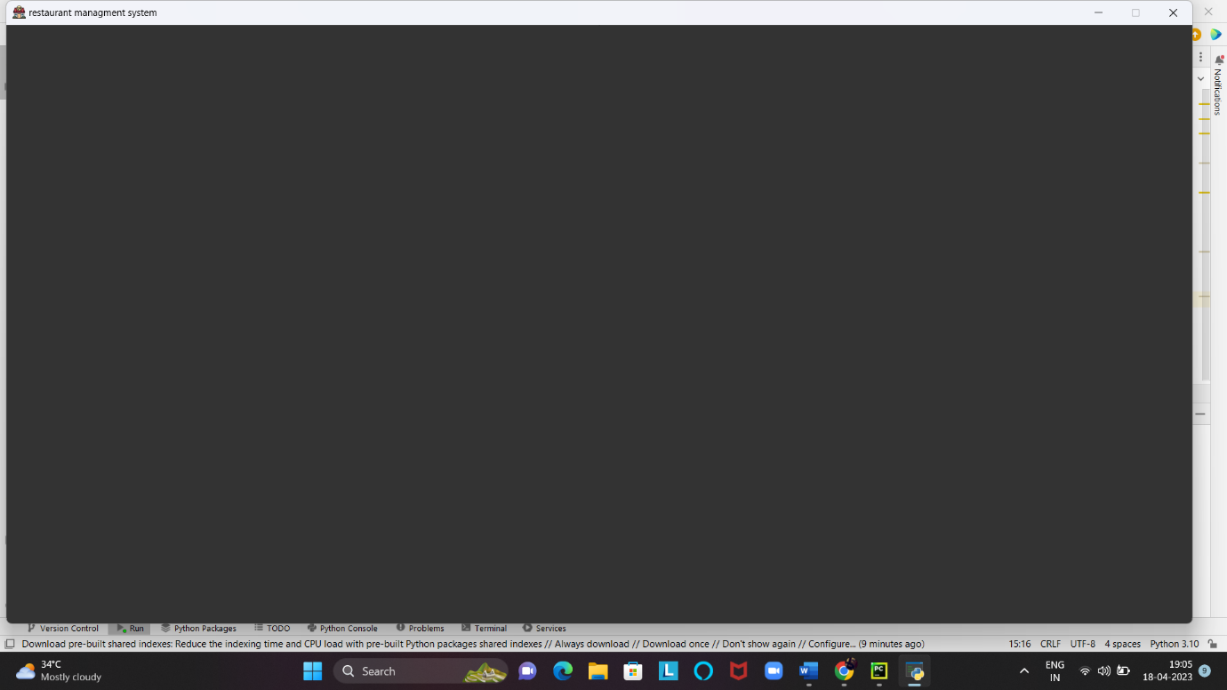

**Add restaurant management system label**

labeltitle=Label(topframe,text=**'Restaurant Management System'**,font=(**'lucida handwriting'**,30,**'bold'**),fg=**'gold'**,  
bg=**'grey20'**,width=52,pady=10)  
labeltitle.grid(row=0,column=0)

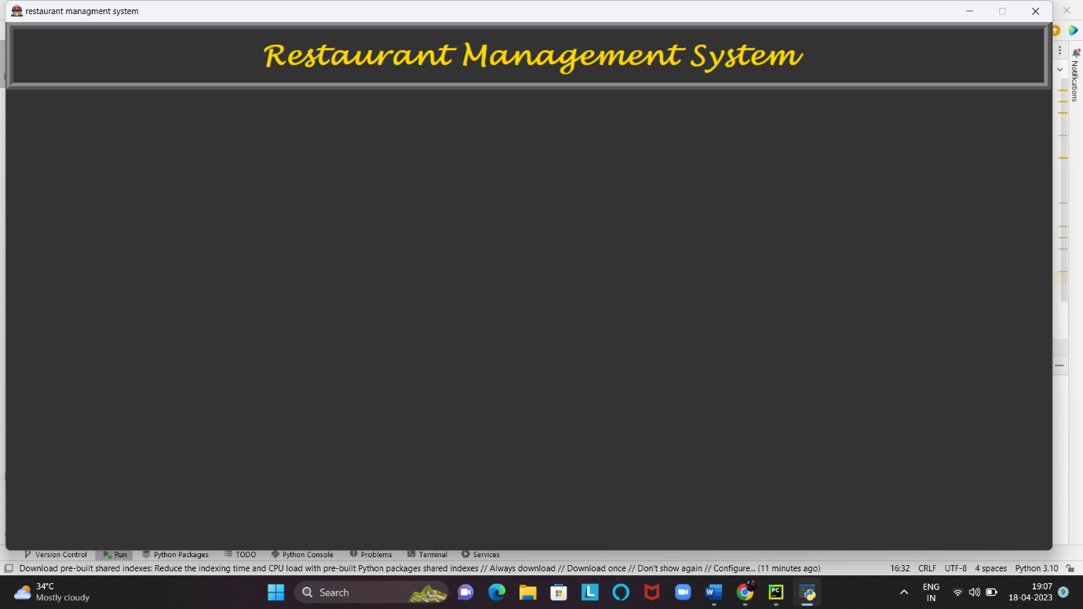

**Add all frames:-**

*# all frames  
#left sides frames*menuframe=Frame(root,bd=10,relief=RIDGE,bg=**"grey20"**)  
menuframe.pack(side=LEFT)  
  
costframe=Frame(menuframe,bd=5,relief=RIDGE,bg=**'grey20'**,pady=28)  
costframe.pack(side=BOTTOM)  
  
foodframe=LabelFrame(menuframe,text=**'Food'**,bd=10,relief=RIDGE,font=(**'lucida handwriting'**,18,**'bold'**),fg=**'gold'**,  
bg=**'grey20'**)  
foodframe.pack(side=LEFT)  
  
drinkframe=LabelFrame(menuframe,text=**'Drinks'**,bd=10,relief=RIDGE,font=(**'lucida handwriting'**,18,**'bold'**),fg=**'gold'**,  
bg=**'grey20'**)  
drinkframe.pack(side=LEFT)  
  
cakesframe=LabelFrame(menuframe,text=**'Cakes'**,bd=10,relief=RIDGE,font=(**'lucida handwriting'**,18,**'bold'**),fg=**'gold'**,  
bg=**'grey20'**)  
cakesframe.pack(side=LEFT)  
  
*#right side frames*rightframe=Frame(root,bd=10,relief=RIDGE,padx=64,bg=**'grey20'**)  
rightframe.pack(side=RIGHT,pady=45)  
  
calculatorframe=Frame(rightframe,bd=4,relief=RIDGE,bg=**'grey20'**)  
calculatorframe.pack()  
  
recieptframe=Frame(rightframe,relief=RIDGE,bd=4,bg=**'grey20'**)  
recieptframe.pack()  
  
buttonframe=Frame(rightframe,bd=4,relief=RIDGE,bg=**'grey20'**)  
buttonframe.pack()

**Define all the variables :-**

*#all variables*var1=IntVar()  
var2=IntVar()  
var3=IntVar()  
var4=IntVar()  
var5=IntVar()  
var6=IntVar()  
var7=IntVar()  
var8=IntVar()  
var9=IntVar()  
var10=IntVar()  
var11=IntVar()  
var12=IntVar()  
var13=IntVar()  
var14=IntVar()  
var15=IntVar()  
var16=IntVar()  
var17=IntVar()  
var18=IntVar()  
var19=IntVar()  
var20=IntVar()  
var21=IntVar()  
var22=IntVar()  
var23=IntVar()  
var24=IntVar()  
var25=IntVar()  
var26=IntVar()  
var27=IntVar()  
  
*#entry food*e_roti=StringVar()  
e_daal=StringVar()  
e_sabji=StringVar()  
e_fish=StringVar()  
e_kebab=StringVar()  
e_chawal=StringVar()  
e_mutton=StringVar()  
e_panner=StringVar()  
e_chicken=StringVar()  
  
*#entry drinks*e_lassi=StringVar()  
e_coffe=StringVar()  
e_faluda=StringVar()  
e_shikanji=StringVar()  
e_jaljeera=StringVar()  
e_roohafza=StringVar()  
e_masalatea=StringVar()  
e_badammilk=StringVar()  
e_colddrink=StringVar()  
  
*#entry cakes*e_oreo=StringVar()  
e_apple=StringVar()  
e_kitkat=StringVar()  
e_vanilla=StringVar()  
e_banana=StringVar()  
e_brownie=StringVar()  
e_pineapple=StringVar()  
e_chocolate=StringVar()  
e_blackforest=StringVar()  
  
  
costoffoodvar=StringVar()  
costofdrinksvar=StringVar()  
costofcakesvar=StringVar()  
totalcostvar=StringVar()  
gstvar=StringVar()  
subtotalvar=StringVar()

**Add default set values:-**

*# default set value*e_roti.set(**'0'**)  
e_daal.set(**'0'**)  
e_sabji.set(**'0'**)  
e_fish.set(**'0'**)  
e_kebab.set(**'0'**)  
e_chawal.set(**'0'**)  
e_mutton.set(**'0'**)  
e_panner.set(**'0'**)  
e_chicken.set(**'0'**)  
  
e_lassi.set(**'0'**)  
e_coffe.set(**'0'**)  
e_faluda.set(**'0'**)  
e_shikanji.set(**'0'**)  
e_jaljeera.set(**'0'**)  
e_roohafza.set(**'0'**)  
e_masalatea.set(**'0'**)  
e_badammilk.set(**'0'**)  
e_colddrink.set(**'0'**)  
  
e_oreo.set(**'0'**)  
e_apple.set(**'0'**)  
e_kitkat.set(**'0'**)  
e_vanilla.set(**'0'**)  
e_banana.set(**'0'**)  
e_brownie.set(**'0'**)  
e_pineapple.set(**'0'**)  
e_chocolate.set(**'0'**)  
e_blackforest.set(**'0'**)

**Now we create food frame:-**

*#food*roti=Checkbutton(foodframe,text=**'Roti'**,font=(**'universe'** ,18,**'bold'**),offvalue=0,onvalue=1,variable=var1,  
command=roti,bg=**'grey20'**,fg=**'gold'**)  
roti.grid(row=0,column=0,sticky=W)  
  
sabji=Checkbutton(foodframe,text=**'Sabji'**,font=(**'universe'** ,18,**'bold'**),offvalue=0,onvalue=1,variable=var2,  
command=sabji,bg=**'grey20'**,fg=**'gold'**)  
sabji.grid(row=1,column=0,sticky=W)  
  
dall=Checkbutton(foodframe,text=**'Daal'**,font=(**'universe'** ,18,**'bold'**),offvalue=0,onvalue=1,variable=var3,  
command=daal,bg=**'grey20'**,fg=**'gold'**)  
dall.grid(row=2,column=0,sticky=W)  
  
fish=Checkbutton(foodframe,text=**'Fish'**,font=(**'universe'** ,18,**'bold'**),offvalue=0,onvalue=1,variable=var4,  
command=fish,bg=**'grey20'**,fg=**'gold'**)  
fish.grid(row=3,column=0,sticky=W)  
  
kebab=Checkbutton(foodframe,text=**'Kebab'**,font=(**'universe'** ,18,**'bold'**),offvalue=0,onvalue=1,variable=var5,  
command=kebab,bg=**'grey20'**,fg=**'gold'**)  
kebab.grid(row=4,column=0,sticky=W)  
  
chawal=Checkbutton(foodframe,text=**'Chawal'**,font=(**'universe'** ,18,**'bold'**),offvalue=0,onvalue=1,variable=var6,  
command=chawal,bg=**'grey20'**,fg=**'gold'**)  
chawal.grid(row=5,column=0,sticky=W)  
  
mutton=Checkbutton(foodframe,text=**'Mutton'**,font=(**'universe'** ,18,**'bold'**),offvalue=0,onvalue=1,variable=var7,  
command=mutton,bg=**'grey20'**,fg=**'gold'**)  
mutton.grid(row=6,column=0,sticky=W)  
  
panner=Checkbutton(foodframe,text=**'Paneer'**,font=(**'universe'** ,18,**'bold'**),offvalue=0,onvalue=1,variable=var8,  
command=panner,bg=**'grey20'**,fg=**'gold'**)  
panner.grid(row=7,column=0,sticky=W)  
  
chicken=Checkbutton(foodframe,text=**'Chicken'**,font=(**'universe'** ,18,**'bold'**),offvalue=0,onvalue=1,variable=var9,  
command=chicken,bg=**'grey20'**,fg=**'gold'**)  
chicken.grid(row=8,column=0,sticky=W)  
  
  
  
  
*#entry*textroti=Entry(foodframe,font=(**'universe'**,18,**'bold'**),bd=7,width=5,state=DISABLED,textvariable=e_roti)  
textroti.grid(row=0,column=1)  
  
textsabji=Entry(foodframe,font=(**'universe'**,18,**'bold'**),bd=7,width=5,state=DISABLED,textvariable=e_sabji)  
textsabji.grid(row=1,column=1)  
  
textdaal=Entry(foodframe,font=(**'universe'**,18,**'bold'**),bd=7,width=5,state=DISABLED,textvariable=e_daal)  
textdaal.grid(row=2,column=1)  
  
textfish=Entry(foodframe,font=(**'universe'**,18,**'bold'**),bd=7,width=5,state=DISABLED,textvariable=e_fish)  
textfish.grid(row=3,column=1)  
  
textkebab=Entry(foodframe,font=(**'universe'**,18,**'bold'**),bd=7,width=5,state=DISABLED,textvariable=e_kebab)  
textkebab.grid(row=4,column=1)  
  
textchawal=Entry(foodframe,font=(**'universe'**,18,**'bold'**),bd=7,width=5,state=DISABLED,textvariable=e_chawal)  
textchawal.grid(row=5,column=1)  
  
textmutton=Entry(foodframe,font=(**'universe'**,18,**'bold'**),bd=7,width=5,state=DISABLED,textvariable=e_mutton)  
textmutton.grid(row=6,column=1)  
  
textpanner=Entry(foodframe,font=(**'universe'**,18,**'bold'**),bd=7,width=5,state=DISABLED,textvariable=e_panner)  
textpanner.grid(row=7,column=1)  
  
textchicken=Entry(foodframe,font=(**'universe'**,18,**'bold'**),bd=7,width=5,state=DISABLED,textvariable=e_chicken)  
textchicken.grid(row=8,column=1)

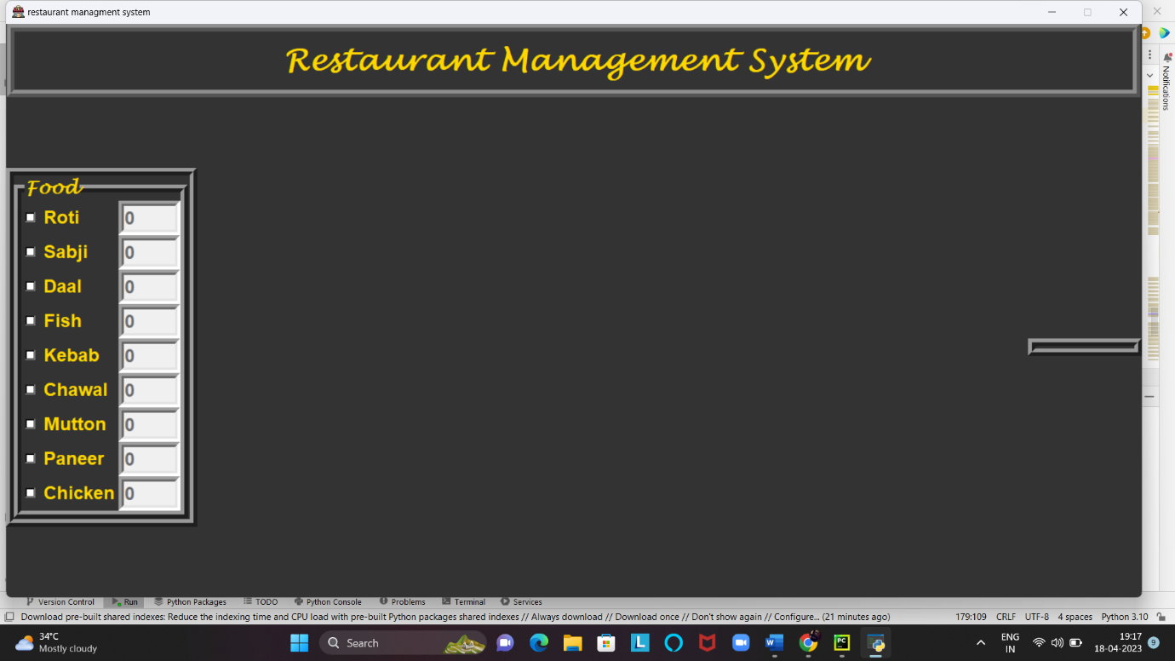

**Create drinks frame:-**

*#drinks*lassi=Checkbutton(drinkframe,text=**'Lassi'**,font=(**'universe'** ,18,**'bold'**),offvalue=0,onvalue=1,variable=var10,  
command=lassi,bg=**'grey20'**,fg=**'gold'**)  
lassi.grid(row=0,column=0,sticky=W)  
  
coffe=Checkbutton(drinkframe,text=**'Coffee'**,font=(**'universe'** ,18,**'bold'**),offvalue=0,onvalue=1,variable=var11,  
command=coffe,bg=**'grey20'**,fg=**'gold'**)  
coffe.grid(row=1,column=0,sticky=W)  
  
faluda=Checkbutton(drinkframe,text=**'Faluda'**,font=(**'universe'** ,18,**'bold'**),offvalue=0,onvalue=1,variable=var12,  
command=faluda,bg=**'grey20'**,fg=**'gold'**)  
faluda.grid(row=2,column=0,sticky=W)  
  
shikanji=Checkbutton(drinkframe,text=**'Shikanji'**,font=(**'universe'** ,18,**'bold'**),offvalue=0,onvalue=1,variable=var13,  
command=shikanji,bg=**'grey20'**,fg=**'gold'**)  
shikanji.grid(row=3,column=0,sticky=W)  
  
jaljeera=Checkbutton(drinkframe,text=**'Jaljeera'**,font=(**'universe'** ,18,**'bold'**),offvalue=0,onvalue=1,variable=var14,  
command=jaljeera,bg=**'grey20'**,fg=**'gold'**)  
jaljeera.grid(row=4,column=0,sticky=W)  
  
roohafza=Checkbutton(drinkframe,text=**'Roohafza'**,font=(**'universe'** ,18,**'bold'**),offvalue=0,onvalue=1,variable=var15,  
command=roohafza,bg=**'grey20'**,fg=**'gold'**)  
roohafza.grid(row=5,column=0,sticky=W)  
  
masalatea=Checkbutton(drinkframe,text=**'Masala tea'**,font=(**'universe'** ,18,**'bold'**),offvalue=0,onvalue=1,variable=var16,  
command=masalatea,bg=**'grey20'**,fg=**'gold'**)  
masalatea.grid(row=6,column=0,sticky=W)  
  
badammilk=Checkbutton(drinkframe,text=**'Badam milk'**,font=(**'universe'** ,18,**'bold'**),offvalue=0,onvalue=1,variable=var17,  
command=badammilk,bg=**'grey20'**,fg=**'gold'**)  
badammilk.grid(row=7,column=0,sticky=W)  
  
colddrink=Checkbutton(drinkframe,text=**'Cold drink'**,font=(**'universe'** ,18,**'bold'**),offvalue=0,onvalue=1,variable=var18,  
command=colddrink,bg=**'grey20'**,fg=**'gold'**)  
colddrink.grid(row=8,column=0,sticky=W)  
  
*#entry drinks*textlassi=Entry(drinkframe,font=(**'universe'**,18,**'bold'**),bd=7,width=5,state=DISABLED,textvariable=e_lassi)  
textlassi.grid(row=0,column=1)  
  
textcoffe=Entry(drinkframe,font=(**'universe'**,18,**'bold'**),bd=7,width=5,state=DISABLED,textvariable=e_coffe)  
textcoffe.grid(row=1,column=1)  
  
textfaluda=Entry(drinkframe,font=(**'universe'**,18,**'bold'**),bd=7,width=5,state=DISABLED,textvariable=e_faluda)  
textfaluda.grid(row=2,column=1)  
  
textshikanji=Entry(drinkframe,font=(**'universe'**,18,**'bold'**),bd=7,width=5,state=DISABLED,textvariable=e_shikanji)  
textshikanji.grid(row=3,column=1)  
  
textjaljeera=Entry(drinkframe,font=(**'universe'**,18,**'bold'**),bd=7,width=5,state=DISABLED,textvariable=e_jaljeera)  
textjaljeera.grid(row=4,column=1)  
  
textroohafza=Entry(drinkframe,font=(**'universe'**,18,**'bold'**),bd=7,width=5,state=DISABLED,textvariable=e_roohafza)  
textroohafza.grid(row=5,column=1)  
  
textmasalatea=Entry(drinkframe,font=(**'universe'**,18,**'bold'**),bd=7,width=5,state=DISABLED,textvariable=e_masalatea)  
textmasalatea.grid(row=6,column=1)  
  
textbadammilk=Entry(drinkframe,font=(**'universe'**,18,**'bold'**),bd=7,width=5,state=DISABLED,textvariable=e_badammilk)  
textbadammilk.grid(row=7,column=1)  
  
textcolddrink=Entry(drinkframe,font=(**'universe'**,18,**'bold'**),bd=7,width=5,state=DISABLED,textvariable=e_colddrink)  
textcolddrink.grid(row=8,column=1)

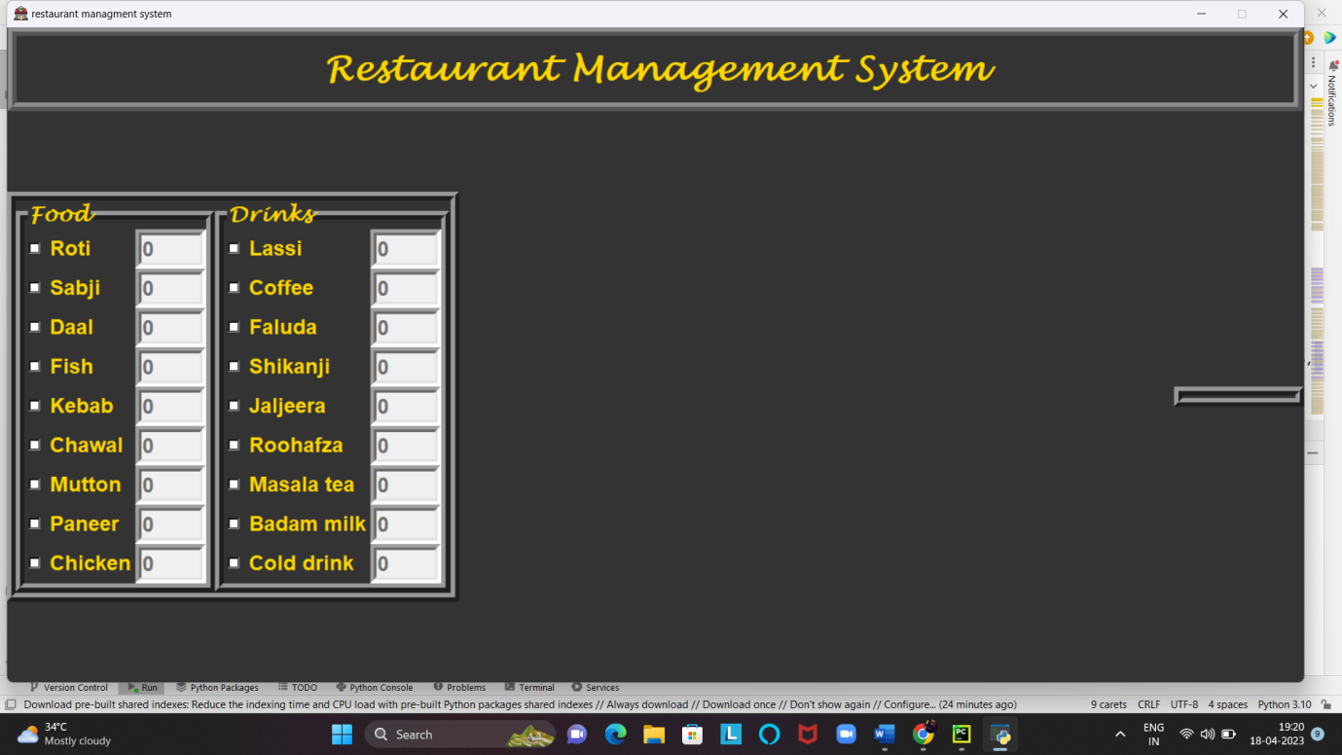

**Create cakes frame:-**

*#cakes*oreo=Checkbutton(cakesframe,text=**'Oreo'**,font=(**'universe'** ,18,**'bold'**),offvalue=0,onvalue=1,variable=var19,  
command=oreo,bg=**'grey20'**,fg=**'gold'**)  
oreo.grid(row=0,column=0,sticky=W)  
  
apple=Checkbutton(cakesframe,text=**'Apple'**,font=(**'universe'** ,18,**'bold'**),offvalue=0,onvalue=1,variable=var20,  
command=apple,bg=**'grey20'**,fg=**'gold'**)  
apple.grid(row=1,column=0,sticky=W)  
  
kitkat=Checkbutton(cakesframe,text=**'Kitkat'**,font=(**'universe'** ,18,**'bold'**),offvalue=0,onvalue=1,variable=var21,  
command=kitkat,bg=**'grey20'**,fg=**'gold'**)  
kitkat.grid(row=2,column=0,sticky=W)  
  
vanilla=Checkbutton(cakesframe,text=**'Vanilla'**,font=(**'universe'** ,18,**'bold'**),offvalue=0,onvalue=1,variable=var22,  
command=vanilla,bg=**'grey20'**,fg=**'gold'**)  
vanilla.grid(row=3,column=0,sticky=W)  
  
banana=Checkbutton(cakesframe,text=**'Banana'**,font=(**'universe'** ,18,**'bold'**),offvalue=0,onvalue=1,variable=var23,  
command=banana,bg=**'grey20'**,fg=**'gold'**)  
banana.grid(row=4,column=0,sticky=W)  
  
brownie=Checkbutton(cakesframe,text=**'Brownie'**,font=(**'universe'** ,18,**'bold'**),offvalue=0,onvalue=1,variable=var24,  
command=brownie,bg=**'grey20'**,fg=**'gold'**)  
brownie.grid(row=5,column=0,sticky=W)  
  
pineapple=Checkbutton(cakesframe,text=**'Pineapple'**,font=(**'universe'** ,18,**'bold'**),offvalue=0,onvalue=1,variable=var25,  
command=pineapple,bg=**'grey20'**,fg=**'gold'**)  
pineapple.grid(row=6,column=0,sticky=W)  
  
chocolate=Checkbutton(cakesframe,text=**'Chocolate'**,font=(**'universe'** ,18,**'bold'**),offvalue=0,onvalue=1,variable=var26,  
command=chocolate,bg=**'grey20'**,fg=**'gold'**)  
chocolate.grid(row=7,column=0,sticky=W)  
  
blackforest=Checkbutton(cakesframe,text=**'Blackforest'**,font=(**'universe'** ,18,**'bold'**),offvalue=0,onvalue=1,  
variable=var27,command=blackforest,bg=**'grey20'**,fg=**'gold'**)  
blackforest.grid(row=8,column=0,sticky=W)  
  
*#entry cakes*textoreo=Entry(cakesframe,font=(**'universe'**,18,**'bold'**),bd=7,width=5,state=DISABLED,textvariable=e_oreo)  
textoreo.grid(row=0,column=1)  
  
textapple=Entry(cakesframe,font=(**'universe'**,18,**'bold'**),bd=7,width=5,state=DISABLED,textvariable=e_apple)  
textapple.grid(row=1,column=1)  
  
textkitkat=Entry(cakesframe,font=(**'universe'**,18,**'bold'**),bd=7,width=5,state=DISABLED,textvariable=e_kitkat)  
textkitkat.grid(row=2,column=1)  
  
textvanilla=Entry(cakesframe,font=(**'universe'**,18,**'bold'**),bd=7,width=5,state=DISABLED,textvariable=e_vanilla)  
textvanilla.grid(row=3,column=1)  
  
textbanana=Entry(cakesframe,font=(**'universe'**,18,**'bold'**),bd=7,width=5,state=DISABLED,textvariable=e_banana)  
textbanana.grid(row=4,column=1)  
  
textbrownie=Entry(cakesframe,font=(**'universe'**,18,**'bold'**),bd=7,width=5,state=DISABLED,textvariable=e_brownie)  
textbrownie.grid(row=5,column=1)  
  
textpineapple=Entry(cakesframe,font=(**'universe'**,18,**'bold'**),bd=7,width=5,state=DISABLED,textvariable=e_pineapple)  
textpineapple.grid(row=6,column=1)  
  
textchocolate=Entry(cakesframe,font=(**'universe'**,18,**'bold'**),bd=7,width=5,state=DISABLED,textvariable=e_chocolate)  
textchocolate.grid(row=7,column=1)  
  
textblackforest=Entry(cakesframe,font=(**'universe'**,18,**'bold'**),bd=7,width=5,state=DISABLED,textvariable=e_blackforest)  
textblackforest.grid(row=8,column=1)

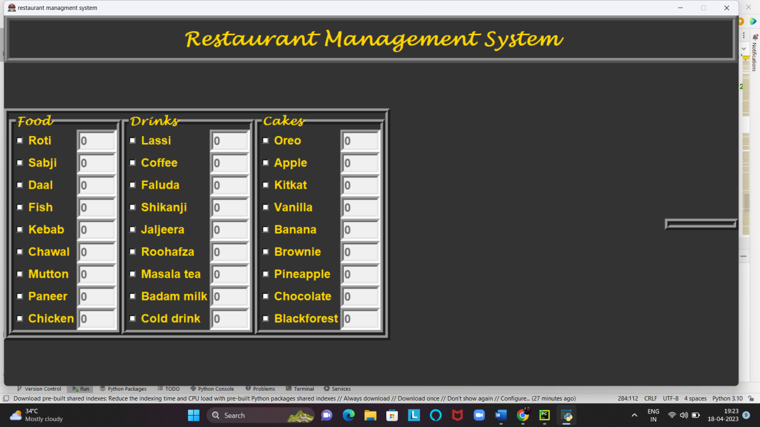

**Create cost frame:-**

*#cost frame*labelcostoffood=Label(costframe,text=**'Cost Of Food'**,font=(**'universe'**,15,**'bold'**),bg=**'grey20'**,fg=**'gold'**)  
labelcostoffood.grid(row=0,column=0)  
textcostoffood=Entry(costframe,font=(**'universe'**,18,**'bold'**),bd=4,width=14,state=**'readonly'**,textvariable=costoffoodvar)  
textcostoffood.grid(row=0,column=1,padx=27)  
  
labelcostofdrinks=Label(costframe,text=**'Cost Of Drinks'**,font=(**'universe'**,15,**'bold'**),bg=**'grey20'**,fg=**'gold'**)  
labelcostofdrinks.grid(row=1,column=0)  
textcostofdrinks=Entry(costframe,font=(**'universe'**,18,**'bold'**),bd=4,width=14,state=**'readonly'**,textvariable=costofdrinksvar)  
textcostofdrinks.grid(row=1,column=1,padx=27)  
  
labelcostofcakes=Label(costframe,text=**'Cost Of Cakes'**,font=(**'universe'**,15,**'bold'**),bg=**'grey20'**,fg=**'gold'**)  
labelcostofcakes.grid(row=2,column=0)  
textcostofcakes=Entry(costframe,font=(**'universe'**,18,**'bold'**),bd=4,width=14,state=**'readonly'**,textvariable=costofcakesvar)  
textcostofcakes.grid(row=2,column=1,padx=27)  
  
labelsubtotal=Label(costframe,text=**'Sub Total'**,font=(**'universe'**,15,**'bold'**),bg=**'grey20'**,fg=**'gold'**)  
labelsubtotal.grid(row=0,column=2)  
textsubtotal=Entry(costframe,font=(**'universe'**,18,**'bold'**),bd=4,width=14,state=**'readonly'**,textvariable=subtotalvar)  
textsubtotal.grid(row=0,column=3,padx=27)  
  
labelgst=Label(costframe,text=**'GST'**,font=(**'universe'**,15,**'bold'**),bg=**'grey20'**,fg=**'gold'**)  
labelgst.grid(row=1,column=2)  
textgst=Entry(costframe,font=(**'universe'**,18,**'bold'**),bd=4,width=14,state=**'readonly'**,textvariable=gstvar)  
textgst.grid(row=1,column=3,padx=27)  
  
labeltotalcost=Label(costframe,text=**'Total Cost'**,font=(**'universe'**,15,**'bold'**),bg=**'grey20'**,fg=**'gold'**)  
labeltotalcost.grid(row=2,column=2)  
texttotalcost=Entry(costframe,font=(**'universe'**,18,**'bold'**),bd=4,width=14,state=**'readonly'**,textvariable=totalcostvar)  
texttotalcost.grid(row=2,column=3,padx=27)

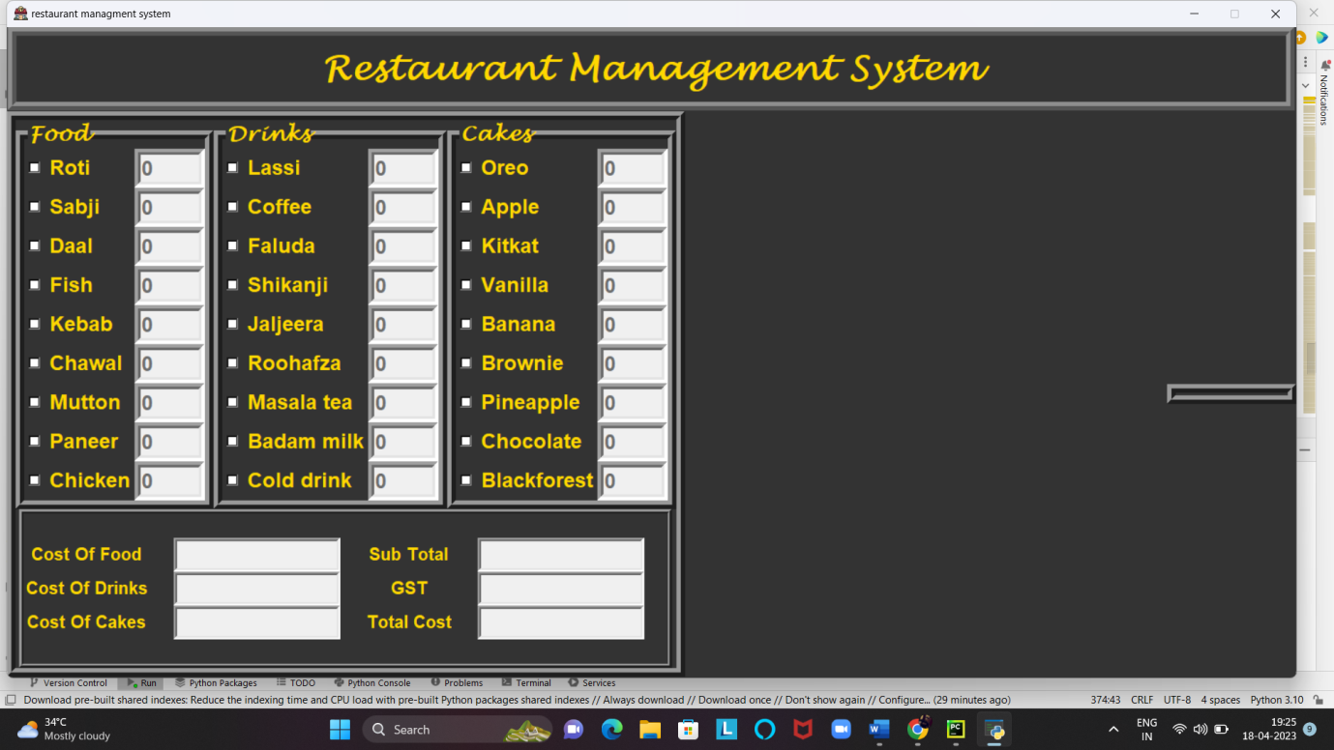

**Now we create Buttons:-**

*#buttons*buttontotal=Button(buttonframe,text=**'Total'**,font=(**'universe'**,14,**'bold'**),bd=3,fg=**'yellow'**,bg=**'grey20'**,padx=32,  
command=totalcost)  
buttontotal.grid(row=0,column=0)  
  
buttonreceipt=Button(buttonframe,text=**'Receipt'**,font=(**'universe'**,14,**'bold'**),bd=3,fg=**'gold'**,bg=**'grey20'**,padx=15,  
command=receipt)  
buttonreceipt.grid(row=0,column=1)  
  
buttonsend=Button(buttonframe,text=**'Send'**,font=(**'universe'**,14,**'bold'**),bd=3,fg=**'gold'**,bg=**'grey20'**,padx=15,  
command=send)  
buttonsend.grid(row=0,column=2)  
  
buttonsave=Button(buttonframe,text=**'Save'**,font=(**'universe'**,14,**'bold'**),bd=3,fg=**'gold'**,bg=**'grey20'**,padx=15,  
command=save)  
buttonsave.grid(row=0,column=3)  
  
buttonreset=Button(buttonframe,text=**'Reset'**,font=(**'universe'**,14,**'bold'**),bd=3,fg=**'gold'**,bg=**'grey20'**,padx=15  
,command=reset)  
buttonreset.grid(row=0,column=4)  
  
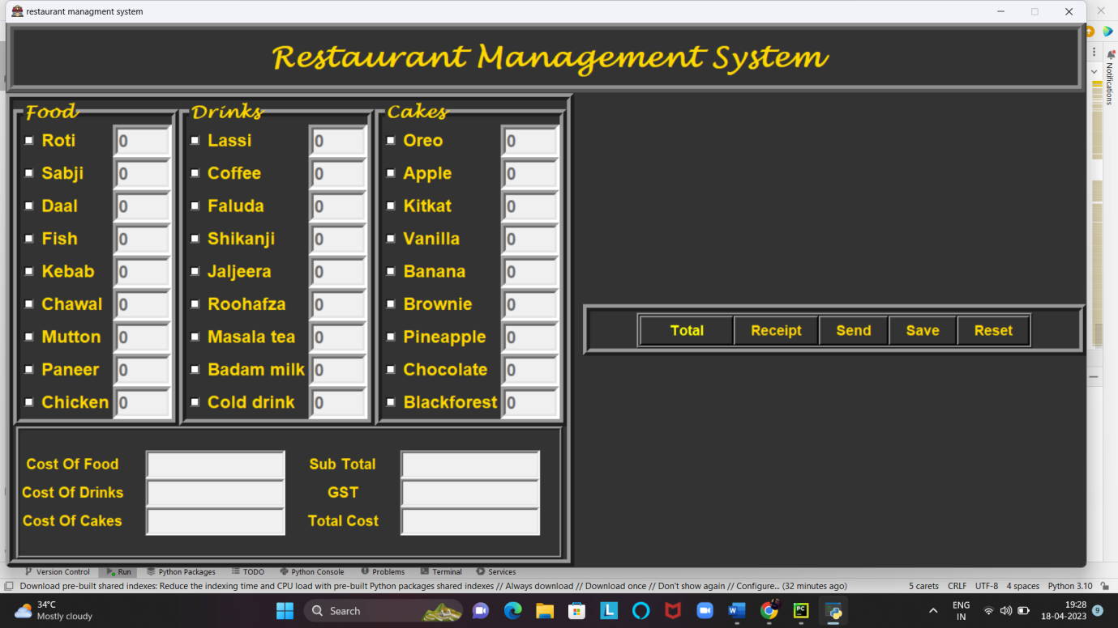

**Add text area for receipt:-**

*#text area for receipt*textreceipt=Text(recieptframe,font=(**'universe'**,12,**'bold'**),bd=3,width=55,height=10)  
textreceipt.grid(row=0,column=0)

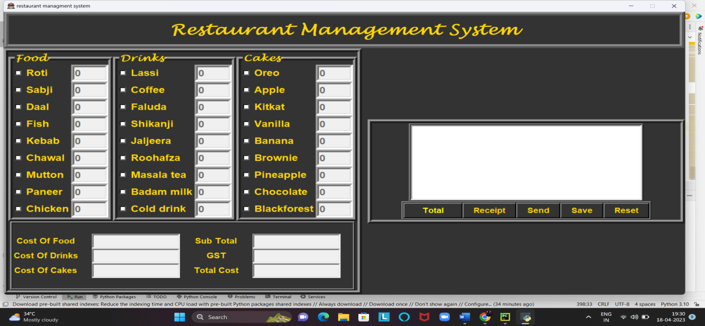

**Now we create calculator :-**

*#calculator*operator=**''  
def** buttonclick(number):  
**global** operator  
 operator=operator+number  
 calculatorfield.delete(0,END)  
 calculatorfield.insert(END,operator)  
**def** clear():  
**global** operator  
 calculatorfield.delete(0,END)  
 operator=**''  
def** ans():  
**global** operator  
 result=str(eval(operator))  
 calculatorfield.delete(0,END)  
 calculatorfield.insert(0,result)  
 operator=**''**calculatorfield=Entry(calculatorframe,font=(**'universe'**,18,**'bold'**),width=40,bd=5)  
calculatorfield.grid(row=0,column=0,columnspan=4)  
  
button7=Button(calculatorframe,text=**'7'**,bd=5,fg=**'gold'**,bg=**'grey20'**,font=(**'universe'**,16,**'bold'**),width=9,  
command=**lambda**:buttonclick(**'7'**))  
button7.grid(row=1,column=0)  
  
button8=Button(calculatorframe,text=**'8'**,bd=5,fg=**'gold'**,bg=**'grey20'**,font=(**'universe'**,16,**'bold'**),width=9,  
command=**lambda**:buttonclick(**'8'**))  
button8.grid(row=1,column=1)  
  
button9=Button(calculatorframe,text=**'9'**,bd=5,fg=**'gold'**,bg=**'grey20'**,font=(**'universe'**,16,**'bold'**),width=9,  
command=**lambda**:buttonclick(**'9'**))  
button9.grid(row=1,column=2)  
  
buttonplus=Button(calculatorframe,text=**'+'**,bd=5,fg=**'gold'**,bg=**'grey20'**,font=(**'universe'**,16,**'bold'**),width=9,  
command=**lambda**:buttonclick(**'+'**))  
buttonplus.grid(row=1,column=3)  
  
button4=Button(calculatorframe,text=**'4'**,bd=5,fg=**'gold'**,bg=**'grey20'**,font=(**'universe'**,16,**'bold'**),width=9,  
command=**lambda**:buttonclick(**'4'**))  
button4.grid(row=2,column=0)  
  
button5=Button(calculatorframe,text=**'5'**,bd=5,fg=**'gold'**,bg=**'grey20'**,font=(**'universe'**,16,**'bold'**),width=9,  
command=**lambda**:buttonclick(**'5'**))  
button5.grid(row=2,column=1)  
  
button6=Button(calculatorframe,text=**'6'**,bd=5,fg=**'gold'**,bg=**'grey20'**,font=(**'universe'**,16,**'bold'**),width=9,  
command=**lambda**:buttonclick(**'6'**))  
button6.grid(row=2,column=2)  
  
buttonminus=Button(calculatorframe,text=**'-'**,bd=5,fg=**'gold'**,bg=**'grey20'**,font=(**'universe'**,16,**'bold'**),width=9,  
command=**lambda**:buttonclick(**'-'**))  
buttonminus.grid(row=2,column=3)  
  
button1=Button(calculatorframe,text=**'1'**,bd=5,fg=**'gold'**,bg=**'grey20'**,font=(**'universe'**,16,**'bold'**),width=9,  
command=**lambda**:buttonclick(**'1'**))  
button1.grid(row=3,column=0)  
  
button2=Button(calculatorframe,text=**'2'**,bd=5,fg=**'gold'**,bg=**'grey20'**,font=(**'universe'**,16,**'bold'**),width=9,  
command=**lambda**:buttonclick(**'2'**))  
button2.grid(row=3,column=1)  
  
button3=Button(calculatorframe,text=**'3'**,bd=5,fg=**'gold'**,bg=**'grey20'**,font=(**'universe'**,16,**'bold'**),width=9,  
command=**lambda**:buttonclick(**'3'**))  
button3.grid(row=3,column=2)  
  
buttonmul=Button(calculatorframe,text=**'*'**,bd=5,fg=**'gold'**,bg=**'grey20'**,font=(**'universe'**,16,**'bold'**),width=9,  
command=**lambda**:buttonclick(**'*'**))  
buttonmul.grid(row=3,column=3)  
  
buttonans=Button(calculatorframe,text=**'Ans'**,bd=5,fg=**'gold'**,bg=**'grey20'**,font=(**'universe'**,16,**'bold'**),width=9,  
command=ans)  
buttonans.grid(row=4,column=0)  
  
buttonclear=Button(calculatorframe,text=**'Clear'**,bd=5,fg=**'gold'**,bg=**'grey20'**,font=(**'universe'**,16,**'bold'**),width=9,  
command=clear)  
buttonclear.grid(row=4,column=1)  
  
buttonzero=Button(calculatorframe,text=**'0'**,bd=5,fg=**'gold'**,bg=**'grey20'**,font=(**'universe'**,16,**'bold'**),width=9,  
command=**lambda**:buttonclick(**'0'**))  
buttonzero.grid(row=4,column=2)  
  
buttondivison=Button(calculatorframe,text=**'/'**,bd=5,fg=**'gold'**,bg=**'grey20'**,font=(**'universe'**,16,**'bold'**),width=9,  
command=**lambda**:buttonclick(**'/'**))  
buttondivison.grid(row=4,column=3)

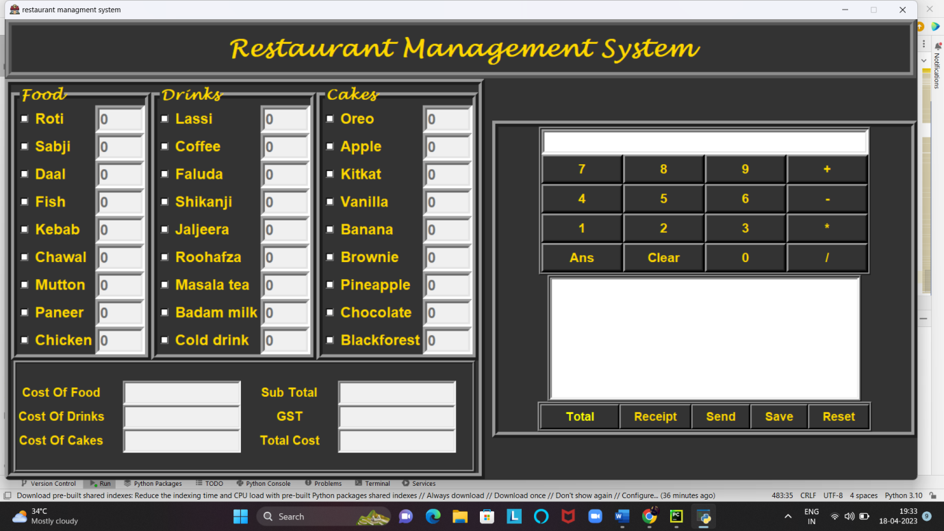

**Now we create back-end:-**

**Defining the Total button function:-**

**def** totalcost():  
**global** priceoffood, priceofdrinks ,priceofcakes,subtotalitems,gstamount,totalcost  
**if** var1.get() != 0 **or** var2.get() != 0 **or** var3.get() != 0 **or** var4.get() != 0 **or** var5.get() != 0 **or** var6.get() != 0 \  
**or** var7.get() != 0 **or** var8.get() != 0 **or** var9.get() != 0 **or** var10.get() != 0 **or** var11.get() != 0 **or** var12.get() != 0 \  
**or** var13.get() != 0 **or** var14.get() != 0 **or** var15.get() != 0 **or** var16.get() != 0 **or** var17.get() != 0 **or** var18.get() != 0 \  
**or** var19.get() != 0 **or** var20.get() != 0 **or** var21.get() != 0 **or** var22.get() != 0 **or** var23.get() != 0 **or** var24.get() != 0 \  
**or** var25.get() != 0 **or** var26.get() != 0 **or** var27.get() != 0:  
  
 item1=int(e_roti.get())  
 item2=int(e_sabji.get())  
 item3=int(e_daal.get())  
 item4 = int(e_fish.get())  
 item5 = int(e_kebab.get())  
 item6 = int(e_chawal.get())  
 item7 = int(e_mutton.get())  
 item8 = int(e_panner.get())  
 item9 = int(e_chicken.get())  
  
 item10 = int(e_lassi.get())  
 item11 = int(e_coffe.get())  
 item12 = int(e_faluda.get())  
 item13 = int(e_shikanji.get())  
 item14 = int(e_jaljeera.get())  
 item15 = int(e_roohafza.get())  
 item16 = int(e_masalatea.get())  
 item17= int(e_badammilk.get())  
 item18 = int(e_colddrink.get())  
  
 item19 = int(e_oreo.get())  
 item20 = int(e_apple.get())  
 item21 = int(e_kitkat.get())  
 item22 = int(e_vanilla.get())  
 item23 = int(e_banana.get())  
 item24 = int(e_brownie.get())  
 item25= int(e_pineapple.get())  
 item26= int(e_chocolate.get())  
 item27= int(e_blackforest.get())  
  
 priceoffood=(item1*10)+(item2*100)+(item3*80)+(item4*300)+(item5*250)+(item6*100)+(item7*350)+(item8*200)\  
 +(item9*250)  
 priceofdrinks=(item10*50)+(item11*70)+(item12*60)+(item13*30)+(item14*30)+(item15*30)+(item16*25)\  
 +(item17*50)+(item18*25)  
 priceofcakes=(item19*250)+(item20*200)+(item21*300)+(item22*150)+(item23*200)+(item24*400)+(item25*180)\  
 +(item26*300)+(item27*500)  
 costoffoodvar.set(str(priceoffood)+**' RS'**)  
 costofdrinksvar.set(str(priceofdrinks)+ **' RS'**)  
 costofcakesvar.set(str(priceofcakes)+**' RS'**)  
 subtotalitems=priceoffood+priceofdrinks+priceofcakes  
 subtotalvar.set(str(subtotalitems)+ **' RS'**)  
 gstamount=subtotalitems*5/100  
gstvar.set(str(gstamount)+**' RS'**)  
 totalcost=subtotalitems+gstamount  
 totalcostvar.set(str(totalcost)+**' RS'**)  
**else**:  
 messagebox.showerror(**'Error'**,**'No items is select '**)

**Defining the Receipt button function:-**

**def** receipt():  
**global** billnumber,date  
**if** costoffoodvar.get() != **'' or** costofcakesvar.get() !=**'' or** costofdrinksvar.get() != **''**:  
 textreceipt.delete(1.0,END)  
 x=random.randint(100,1000)  
 billnumber=**'BILL'**+str(x)  
 date=time.strftime(**'%d/%m/%Y'**)  
 textreceipt.insert(END,**'Bill reff..\t\t'**+billnumber+**'\t\t\t'**+date+**'\n'**)  
 textreceipt.insert(END,**'**********************************************************************************\n'**)  
 textreceipt.insert(END,**'ITEMS:\t\t\t COST OF ITEMS(RS)\n'**)  
 textreceipt.insert(END, **'**********************************************************************************\n'**)  
**if** e_roti.get()!=**'0'**:  
 textreceipt.insert(END,**f'Roti\t\t\t\t{** int(e_roti.get())*10**}RS\n\n'**)  
**if** e_sabji.get()!=**'0'**:  
 textreceipt.insert(END,**f'Sabji\t\t\t\t{** int(e_sabji.get())*100**}RS\n\n'**)  
**if** e_daal.get()!=**'0'**:  
 textreceipt.insert(END,**f'Daal\t\t\t\t{** int(e_daal.get())*80**}RS\n\n'**)  
**if** e_fish.get()!=**'0'**:  
 textreceipt.insert(END,**f'Fish\t\t\t\t{** int(e_fish.get())*300**}RS\n\n'**)  
**if** e_kebab.get()!=**'0'**:  
 textreceipt.insert(END,**f'Kebab\t\t\t\t{** int(e_kebab.get())*250**}RS\n\n'**)  
**if** e_chawal.get()!=**'0'**:  
 textreceipt.insert(END,**f'Chawal\t\t\t\t{** int(e_chawal.get())*100**}RS\n\n'**)  
**if** e_mutton.get()!=**'0'**:  
 textreceipt.insert(END,**f'Mutton\t\t\t\t{** int(e_mutton.get())*350**}RS\n\n'**)  
**if** e_panner.get()!=**'0'**:  
 textreceipt.insert(END,**f'Panner\t\t\t\t{** int(e_panner.get())*200**}RS\n\n'**)  
**if** e_chicken.get()!=**'0'**:  
 textreceipt.insert(END,**f'Chicken\t\t\t\t{** int(e_chicken.get())*250**}RS\n\n'**)  
  
**if** e_lassi.get()!=**'0'**:  
 textreceipt.insert(END,**f'Lassi\t\t\t\t{** int(e_lassi.get())*50**}RS\n\n'**)  
**if** e_coffe.get()!=**'0'**:  
 textreceipt.insert(END,**f'Coffe\t\t\t\t{** int(e_coffe.get())*70**}RS\n\n'**)  
**if** e_faluda.get()!=**'0'**:  
 textreceipt.insert(END,**f'Faluda\t\t\t\t{** int(e_faluda.get())*60**}RS\n\n'**)  
**if** e_shikanji.get()!=**'0'**:  
 textreceipt.insert(END,**f'Shikanji\t\t\t\t{** int(e_shikanji.get())*30**}RS\n\n'**)  
**if** e_jaljeera.get()!=**'0'**:  
 textreceipt.insert(END,**f'Jaljeera\t\t\t\t{** int(e_jaljeera.get())*30**}RS\n\n'**)  
**if** e_roohafza.get()!=**'0'**:  
 textreceipt.insert(END,**f'Roohafza\t\t\t\t{** int(e_roohafza.get())*30**}RS\n\n'**)  
**if** e_masalatea.get()!=**'0'**:  
 textreceipt.insert(END,**f'Masalatea\t\t\t\t{** int(e_masalatea.get())*25**}RS\n\n'**)  
**if** e_badammilk.get()!=**'0'**:  
 textreceipt.insert(END,**f'Badammilk\t\t\t\t{** int(e_badammilk.get())*50**}RS\n\n'**)  
**if** e_colddrink.get()!=**'0'**:  
 textreceipt.insert(END,**f'Colddrink\t\t\t\t{** int(e_colddrink.get())*25**}RS\n\n'**)  
  
**if** e_oreo.get()!=**'0'**:  
 textreceipt.insert(END,**f'Oreo\t\t\t\t{** int(e_oreo.get())*250**}RS\n\n'**)  
**if** e_apple.get()!=**'0'**:  
 textreceipt.insert(END,**f'Apple\t\t\t\t{** int(e_apple.get())*200**}RS\n\n'**)  
**if** e_kitkat.get()!=**'0'**:  
 textreceipt.insert(END,**f'Kitkat\t\t\t\t{** int(e_kitkat.get())*300**}RS\n\n'**)  
**if** e_vanilla.get()!=**'0'**:  
 textreceipt.insert(END,**f'Vanilla\t\t\t\t{** int(e_vanilla.get())*150**}RS\n\n'**)  
**if** e_banana.get()!=**'0'**:  
 textreceipt.insert(END,**f'Banana\t\t\t\t{** int(e_banana.get())*200**}RS\n\n'**)  
**if** e_brownie.get()!=**'0'**:  
 textreceipt.insert(END,**f'Brownie\t\t\t\t{** int(e_brownie.get())*400**}RS\n\n'**)  
**if** e_pineapple.get()!=**'0'**:  
 textreceipt.insert(END,**f'Pineapple\t\t\t\t{** int(e_pineapple.get())*180**}RS\n\n'**)  
**if** e_chocolate.get()!=**'0'**:  
 textreceipt.insert(END,**f'Chocolate\t\t\t\t{** int(e_chocolate.get())*300**}RS\n\n'**)  
**if** e_blackforest.get()!=**'0'**:  
 textreceipt.insert(END,**f'Blackforest\t\t\t\t{** int(e_blackforest.get())*500**}RS\n\n'**)  
  
 textreceipt.insert(END, **'**********************************************************************************\n'**)  
**if** costoffoodvar.get()!=**'0'**:  
 textreceipt.insert(END,**f'Cost of Food \t\t\t\t {**priceoffood**}RS\n\n'**)  
**if** costofdrinksvar.get()!=**'0'**:  
 textreceipt.insert(END,**f'Cost of Drinks \t\t\t\t {**priceofdrinks**}RS\n\n'**)  
**if** costofcakesvar.get()!=**'0'**:  
 textreceipt.insert(END,**f'Cost of Cakes \t\t\t\t {**priceofcakes**}RS\n\n'**)  
  
 textreceipt.insert(END,**f'Sub Total \t\t\t\t {**subtotalitems**}RS\n\n'**)  
 textreceipt.insert(END,**f'GST \t\t\t\t {**gstamount**}RS\n\n'**)  
 textreceipt.insert(END, **'*********************************************************************************\n'**)  
 textreceipt.insert(END,**f'Total Cost \t\t\t\t {**totalcost**}RS\n\n,'**)  
 textreceipt.insert(END, **'*********************************************************************************\n'**)  
**else**:  
 messagebox.showerror(**'Eror'**,**'No items is select'**)

**Defining the Save button functions:-**

**def** save():  
**if** textreceipt.get(1.0,END) ==**'\n'**:  
**pass  
 else**:  
 url=filedialog.asksaveasfile(mode=**'w'**,defaultextension=**'.txt'**)  
**if** url==**None**:  
**pass  
 else**:  
 bill_data=textreceipt.get(1.0,END)  
 url.write(bill_data)  
 url.close()  
 messagebox.showinfo(**'information'**,**'your bill is succesfully saved'**)

**Defining the Reset button function:-**

**def** reset():  
 textreceipt.delete(1.0,END)  
 e_roti.set(**'0'**)  
 e_daal.set(**'0'**)  
 e_sabji.set(**'0'**)  
 e_fish.set(**'0'**)  
 e_kebab.set(**'0'**)  
 e_chawal.set(**'0'**)  
 e_mutton.set(**'0'**)  
 e_panner.set(**'0'**)  
 e_chicken.set(**'0'**)  
  
 e_lassi.set(**'0'**)  
 e_coffe.set(**'0'**)  
 e_faluda.set(**'0'**)  
 e_shikanji.set(**'0'**)  
 e_jaljeera.set(**'0'**)  
 e_roohafza.set(**'0'**)  
 e_masalatea.set(**'0'**)  
 e_badammilk.set(**'0'**)  
 e_colddrink.set(**'0'**)  
  
 e_oreo.set(**'0'**)  
 e_apple.set(**'0'**)  
 e_kitkat.set(**'0'**)  
 e_vanilla.set(**'0'**)  
 e_banana.set(**'0'**)  
 e_brownie.set(**'0'**)  
 e_pineapple.set(**'0'**)  
 e_chocolate.set(**'0'**)  
 e_blackforest.set(**'0'**)  
  
 textroti.config(state=DISABLED)  
 textdaal.config(state=DISABLED)  
 textsabji.config(state=DISABLED)  
 textfish.config(state=DISABLED)  
 textkebab.config(state=DISABLED)  
 textchawal.config(state=DISABLED)  
 textmutton.config(state=DISABLED)  
 textpanner.config(state=DISABLED)  
 textchicken.config(state=DISABLED)  
  
 textlassi.config(state=DISABLED)  
 textcoffe.config(state=DISABLED)  
 textfaluda.config(state=DISABLED)  
 textshikanji.config(state=DISABLED)  
 textjaljeera.config(state=DISABLED)  
 textroohafza.config(state=DISABLED)  
 textmasalatea.config(state=DISABLED)  
 textbadammilk.config(state=DISABLED)  
 textcolddrink.config(state=DISABLED)  
  
 textoreo.config(state=DISABLED)  
 textapple.config(state=DISABLED)  
 textkitkat.config(state=DISABLED)  
 textvanilla.config(state=DISABLED)  
 textbanana.config(state=DISABLED)  
 textbrownie.config(state=DISABLED)  
 textpineapple.config(state=DISABLED)  
 textchocolate.config(state=DISABLED)  
 textblackforest.config(state=DISABLED)  
  
 var1.set(0)  
 var2.set(0)  
 var3.set(0)  
 var4.set(0)  
 var5.set(0)  
 var6.set(0)  
 var7.set(0)  
 var8.set(0)  
 var9.set(0)  
 var10.set(0)  
 var11.set(0)  
 var12.set(0)  
 var13.set(0)  
 var14.set(0)  
 var15.set(0)  
 var16.set(0)  
 var17.set(0)  
 var18.set(0)  
 var19.set(0)  
 var20.set(0)  
 var21.set(0)  
 var22.set(0)  
 var23.set(0)  
 var24.set(0)  
 var25.set(0)  
 var26.set(0)  
 var27.set(0)  
  
 costoffoodvar.set(**''**)  
 costofdrinksvar.set(**''**)  
 costofcakesvar.set(**''**)  
 subtotalvar.set(**''**)  
 gstvar.set(**''**)  
 totalcostvar.set(**''**)

**Defining the Send button function:-**

**def** send():  
**def** send_email():  
  
*# Email details*sender_email = **'chiragkapoor1711@gmail.com'**sender_password = **'sender_password'**mail=mailentry.get()  
 message=textarea.get(1.0,END)  
 subject = **'Bill'***# SMTP server details*smtp_server = **'smtp.gmail.com'**smtp_port = 587  
  
*# Create a secure SSL context*context = smtplib.SMTP(smtp_server, smtp_port)  
 context.starttls()  
  
*# Login to the email account*context.login(sender_email, sender_password)  
  
*# Create the email message*email_message = **f"Subject: {**subject**}\n\n{**message**}"***# Send the email*context.sendmail(sender_email, mail, email_message)  
  
*# Close the SMTP context*context.quit()  
  
  
 root2=Toplevel()  
 root2.title(**'send bill'**)  
 root2.iconbitmap(**'restaurant.ico'**)  
 root2.config(bg=**'grey20'**)  
 root2.geometry(**'485x620+50+50'**)  
 maillabel=Label(root2,text=**"Enter mail"**,font=(**'universe'**,18,**'bold'**),bg=**'grey20'**,fg=**'gold'**)  
 maillabel.pack(pady=3)  
 mailentry=Entry(root2,font=(**'universe'**,16),border=3,width=25)  
 mailentry.pack(pady=3)  
 maillabel = Label(root2, text=**"Bill details"**, font=(**'universe'**, 18, **'bold'**), bg=**'grey20'**, fg=**'gold'**)  
 maillabel.pack(pady=3)  
 textarea=Text(root2,font=(**'universe'**,12),border=3,height=15,width=35)  
 textarea.pack(pady=3)  
 send_button=Button(root2,font=(**'universe'**,18,**'bold'**),text=**"send"**,relief=GROOVE,bg=**'grey20'**,fg=**'gold'**,  
command=send_email)  
 send_button.pack(pady=3)  
 textarea.insert(END,**'receipt reff. \t\t'**+billnumber+**'\t'**+date+**'\n\n'**)  
**if** costoffoodvar.get() != **'0'**:  
 textarea.insert(END, **f'Cost of food \t\t\t {**priceoffood**}RS\n'**)  
**if** costofdrinksvar.get() != **'0'**:  
 textarea.insert(END, **f'Cost of Drinks \t\t\t {**priceofdrinks**}RS\n'**)  
**if** costofcakesvar.get() != **'0'**:  
 textarea.insert(END, **f'Cost of cakes \t\t\t {**priceofcakes**}RS\n'**)  
  
 textarea.insert(END, **f'sub total \t\t\t {**subtotalitems**}RS\n'**)  
 textarea.insert(END, **f'GST \t\t\t {**gstamount**}RS\n\n'**)  
 textarea.insert(END, **f'Total cost \t\t\t {**totalcost**}RS\n'**)  
  
 root2.mainloop()

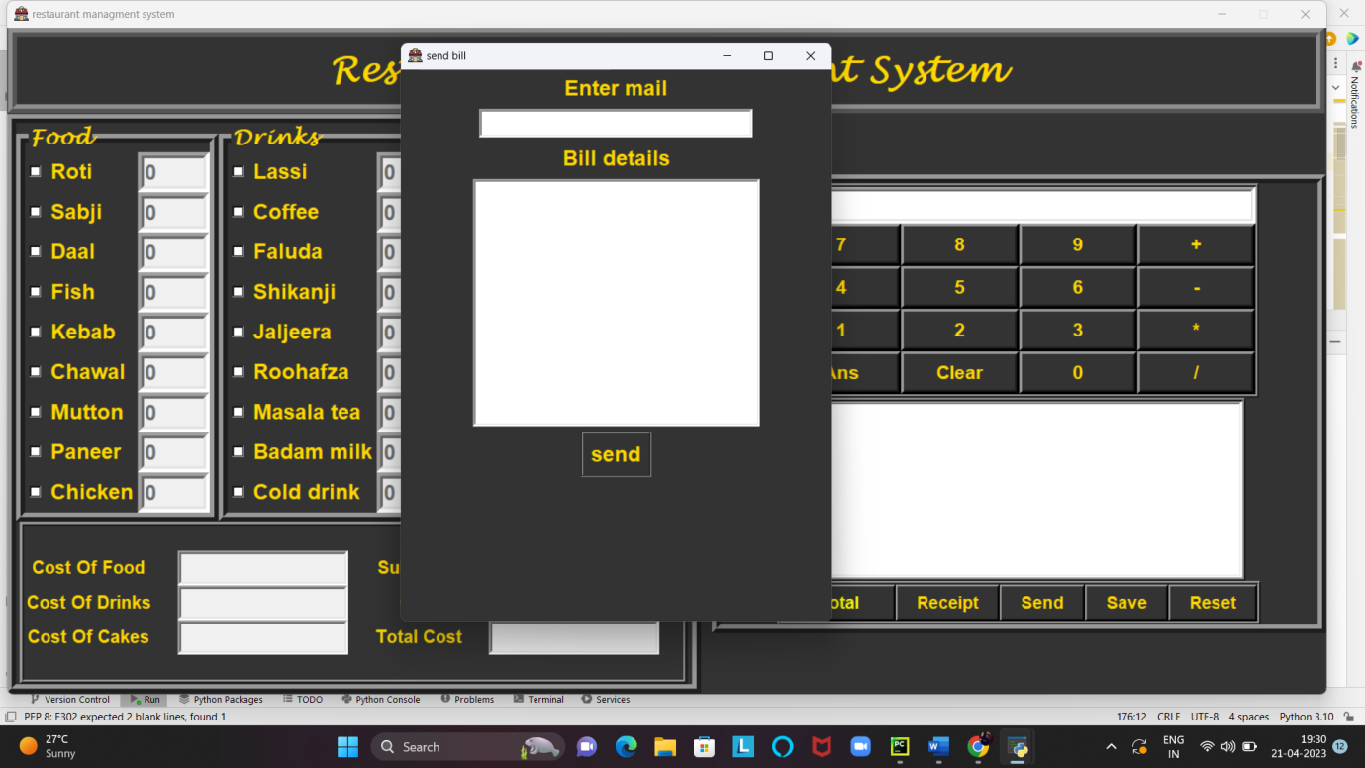

**Defining all the items in menu functionality:-**

**def** roti():  
**if** var1.get()==1:  
 textroti.config(state=NORMAL)  
 textroti.delete(0,END)  
 textroti.focus()  
**else**:  
 textroti.config(state=DISABLED)  
 e_roti.set(**'0'**)  
  
**def** sabji():  
**if** var2.get()==1:  
 textsabji.config(state=NORMAL)  
 textsabji.delete(0,END)  
 textsabji.focus()  
**else**:  
 textsabji.config(state=DISABLED)  
 e_sabji.set(**'0'**)  
  
**def** daal():  
**if** var3.get()==1:  
 textdaal.config(state=NORMAL)  
 textdaal.delete(0,END)  
 textdaal.focus()  
**else**:  
 textdaal.config(state=DISABLED)  
 e_daal.set(**'0'**)  
**def** fish():  
**if** var4.get()==1:  
 textfish.config(state=NORMAL)  
 textfish.delete(0,END)  
 textfish.focus()  
**else**:  
 textfish.config(state=DISABLED)  
 e_fish.set(**'0'**)  
**def** kebab():  
**if** var5.get()==1:  
 textkebab.config(state=NORMAL)  
 textkebab.delete(0,END)  
 textkebab.focus()  
**else**:  
 textkebab.config(state=DISABLED)  
 e_kebab.set(**'0'**)  
**def** chawal():  
**if** var6.get()==1:  
 textchawal.config(state=NORMAL)  
 textchawal.delete(0,END)  
 textchawal.focus()  
**else**:  
 textchawal.config(state=DISABLED)  
 e_chawal.set(**'0'**)  
**def** mutton():  
**if** var7.get()==1:  
 textmutton.config(state=NORMAL)  
 textmutton.delete(0,END)  
 textmutton.focus()  
**else**:  
 textmutton.config(state=DISABLED)  
 e_mutton.set(**'0'**)  
  
**def** panner():  
**if** var8.get()==1:  
 textpanner.config(state=NORMAL)  
 textpanner.delete(0,END)  
 textpanner.focus()  
**else**:  
 textpanner.config(state=DISABLED)  
 e_panner.set(**'0'**)  
**def** chicken():  
**if** var9.get()==1:  
 textchicken.config(state=NORMAL)  
 textchicken.delete(0,END)  
 textchicken.focus()  
**else**:  
 textchicken.config(state=DISABLED)  
 e_chicken.set(**'0'**)  
  
**def** lassi():  
**if** var10.get()==1:  
 textlassi.config(state=NORMAL)  
 textlassi.delete(0,END)  
 textlassi.focus()  
**else**:  
 textlassi.config(state=DISABLED)  
 e_lassi.set(**'0'**)  
**def** coffe():  
**if** var11.get()==1:  
 textcoffe.config(state=NORMAL)  
 textcoffe.delete(0,END)  
 textcoffe.focus()  
**else**:  
 textcoffe.config(state=DISABLED)  
 e_coffe.set(**'0'**)  
**def** faluda():  
**if** var12.get()==1:  
 textfaluda.config(state=NORMAL)  
 textfaluda.delete(0,END)  
 textfaluda.focus()  
**else**:  
 textfaluda.config(state=DISABLED)  
 e_faluda.set(**'0'**)  
**def** shikanji():  
**if** var13.get()==1:  
 textshikanji.config(state=NORMAL)  
 textshikanji.delete(0,END)  
 textshikanji.focus()  
**else**:  
 textshikanji.config(state=DISABLED)  
 e_shikanji.set(**'0'**)  
**def** jaljeera():  
**if** var14.get()==1:  
 textjaljeera.config(state=NORMAL)  
 textjaljeera.delete(0,END)  
 textjaljeera.focus()  
**else**:  
 textjaljeera.config(state=DISABLED)  
 e_jaljeera.set(**'0'**)  
**def** roohafza():  
**if** var15.get()==1:  
 textroohafza.config(state=NORMAL)  
 textroohafza.delete(0,END)  
 textroohafza.focus()  
**else**:  
 textroohafza.config(state=DISABLED)  
 e_roohafza.set(**'0'**)  
**def** masalatea():  
**if** var16.get()==1:  
 textmasalatea.config(state=NORMAL)  
 textmasalatea.delete(0,END)  
 textmasalatea.focus()  
**else**:  
 textmasalatea.config(state=DISABLED)  
 e_masalatea.set(**'0'**)  
**def** badammilk():  
**if** var17.get()==1:  
 textbadammilk.config(state=NORMAL)  
 textbadammilk.delete(0,END)  
 textbadammilk.focus()  
**else**:  
 textbadammilk.config(state=DISABLED)  
 e_badammilk.set(**'0'**)  
**def** colddrink():  
**if** var18.get()==1:  
 textcolddrink.config(state=NORMAL)  
 textcolddrink.delete(0,END)  
 textcolddrink.focus()  
**else**:  
 textcolddrink.config(state=DISABLED)  
 e_colddrink.set(**'0'**)  
**def** oreo():  
**if** var19.get()==1:  
 textoreo.config(state=NORMAL)  
 textoreo.delete(0,END)  
 textoreo.focus()  
**else**:  
 textoreo.config(state=DISABLED)  
 e_oreo.set(**'0'**)  
**def** apple():  
**if** var20.get()==1:  
 textapple.config(state=NORMAL)  
 textapple.delete(0,END)  
 textapple.focus()  
**else**:  
 textapple.config(state=DISABLED)  
 e_apple.set(**'0'**)  
**def** kitkat():  
**if** var21.get()==1:  
 textkitkat.config(state=NORMAL)  
 textkitkat.delete(0,END)  
 textkitkat.focus()  
**else**:  
 textkitkat.config(state=DISABLED)  
 e_kitkat.set(**'0'**)  
**def** vanilla():  
**if** var22.get()==1:  
 textvanilla.config(state=NORMAL)  
 textvanilla.delete(0,END)  
 textvanilla.focus()  
**else**:  
 textvanilla.config(state=DISABLED)  
 e_vanilla.set(**'0'**)  
**def** banana():  
**if** var23.get()==1:  
 textbanana.config(state=NORMAL)  
 textbanana.delete(0,END)  
 textbanana.focus()  
**else**:  
 textbanana.config(state=DISABLED)  
 e_banana.set(**'0'**)  
**def** brownie():  
**if** var24.get()==1:  
 textbrownie.config(state=NORMAL)  
 textbrownie.delete(0,END)  
 textbrownie.focus()  
**else**:  
 textbrownie.config(state=DISABLED)  
 e_brownie.set(**'0'**)  
**def** pineapple():  
**if** var25.get()==1:  
 textpineapple.config(state=NORMAL)  
 textpineapple.delete(0,END)  
 textpineapple.focus()  
**else**:  
 textpineapple.config(state=DISABLED)  
 e_pineapple.set(**'0'**)  
**def** chocolate():  
**if** var26.get()==1:  
 textchocolate.config(state=NORMAL)  
 textchocolate.delete(0,END)  
 textchocolate.focus()  
**else**:  
 textchocolate.config(state=DISABLED)  
 e_chocolate.set(**'0'**)  
**def** blackforest():  
**if** var27.get()==1:  
 textblackforest.config(state=NORMAL)  
 textblackforest.delete(0,END)  
 textblackforest.focus()  
**else**:  
 textblackforest.config(state=DISABLED)  
 e_blackforest.set(**'0'**)

**Complete Source code of Restaurant management system project in Python:-**

**import** smtplib  
**from** tkinter **import** *  
**import** random  
**import** time  
**from** tkinter **import** filedialog,messagebox  
  
*#functions***def** reset():  
 textreceipt.delete(1.0,END)  
 e_roti.set(**'0'**)  
 e_daal.set(**'0'**)  
 e_sabji.set(**'0'**)  
 e_fish.set(**'0'**)  
 e_kebab.set(**'0'**)  
 e_chawal.set(**'0'**)  
 e_mutton.set(**'0'**)  
 e_panner.set(**'0'**)  
 e_chicken.set(**'0'**)  
  
 e_lassi.set(**'0'**)  
 e_coffe.set(**'0'**)  
 e_faluda.set(**'0'**)  
 e_shikanji.set(**'0'**)  
 e_jaljeera.set(**'0'**)  
 e_roohafza.set(**'0'**)  
 e_masalatea.set(**'0'**)  
 e_badammilk.set(**'0'**)  
 e_colddrink.set(**'0'**)  
  
 e_oreo.set(**'0'**)  
 e_apple.set(**'0'**)  
 e_kitkat.set(**'0'**)  
 e_vanilla.set(**'0'**)  
 e_banana.set(**'0'**)  
 e_brownie.set(**'0'**)  
 e_pineapple.set(**'0'**)  
 e_chocolate.set(**'0'**)  
 e_blackforest.set(**'0'**)  
  
 textroti.config(state=DISABLED)  
 textdaal.config(state=DISABLED)  
 textsabji.config(state=DISABLED)  
 textfish.config(state=DISABLED)  
 textkebab.config(state=DISABLED)  
 textchawal.config(state=DISABLED)  
 textmutton.config(state=DISABLED)  
 textpanner.config(state=DISABLED)  
 textchicken.config(state=DISABLED)  
  
 textlassi.config(state=DISABLED)  
 textcoffe.config(state=DISABLED)  
 textfaluda.config(state=DISABLED)  
 textshikanji.config(state=DISABLED)  
 textjaljeera.config(state=DISABLED)  
 textroohafza.config(state=DISABLED)  
 textmasalatea.config(state=DISABLED)  
 textbadammilk.config(state=DISABLED)  
 textcolddrink.config(state=DISABLED)  
  
 textoreo.config(state=DISABLED)  
 textapple.config(state=DISABLED)  
 textkitkat.config(state=DISABLED)  
 textvanilla.config(state=DISABLED)  
 textbanana.config(state=DISABLED)  
 textbrownie.config(state=DISABLED)  
 textpineapple.config(state=DISABLED)  
 textchocolate.config(state=DISABLED)  
 textblackforest.config(state=DISABLED)  
  
 var1.set(0)  
 var2.set(0)  
 var3.set(0)  
 var4.set(0)  
 var5.set(0)  
 var6.set(0)  
 var7.set(0)  
 var8.set(0)  
 var9.set(0)  
 var10.set(0)  
 var11.set(0)  
 var12.set(0)  
 var13.set(0)  
 var14.set(0)  
 var15.set(0)  
 var16.set(0)  
 var17.set(0)  
 var18.set(0)  
 var19.set(0)  
 var20.set(0)  
 var21.set(0)  
 var22.set(0)  
 var23.set(0)  
 var24.set(0)  
 var25.set(0)  
 var26.set(0)  
 var27.set(0)  
  
 costoffoodvar.set(**''**)  
 costofdrinksvar.set(**''**)  
 costofcakesvar.set(**''**)  
 subtotalvar.set(**''**)  
 gstvar.set(**''**)  
 totalcostvar.set(**''**)  
  
  
**def** send():  
**def** send_email():  
  
*# Email details*sender_email = **'chiragkapoor1711@gmail.com'**sender_password = **'sender_password'**mail=mailentry.get()  
 message=textarea.get(1.0,END)  
 subject = **'Bill'***# SMTP server details*smtp_server = **'smtp.gmail.com'**smtp_port = 587  
  
*# Create a secure SSL context*context = smtplib.SMTP(smtp_server, smtp_port)  
 context.starttls()  
  
*# Login to the email account*context.login(sender_email, sender_password)  
  
*# Create the email message*email_message = **f"Subject: {**subject**}\n\n{**message**}"***# Send the email*context.sendmail(sender_email, mail, email_message)  
  
*# Close the SMTP context*context.quit()  
  
  
 root2=Toplevel()  
 root2.title(**'send bill'**)  
 root2.iconbitmap(**'restaurant.ico'**)  
 root2.config(bg=**'grey20'**)  
 root2.geometry(**'485x620+50+50'**)  
 maillabel=Label(root2,text=**"Enter mail"**,font=(**'universe'**,18,**'bold'**),bg=**'grey20'**,fg=**'gold'**)  
 maillabel.pack(pady=3)  
 mailentry=Entry(root2,font=(**'universe'**,16),border=3,width=25)  
 mailentry.pack(pady=3)  
 maillabel = Label(root2, text=**"Bill details"**, font=(**'universe'**, 18, **'bold'**), bg=**'grey20'**, fg=**'gold'**)  
 maillabel.pack(pady=3)  
 textarea=Text(root2,font=(**'universe'**,12),border=3,height=15,width=35)  
 textarea.pack(pady=3)  
 send_button=Button(root2,font=(**'universe'**,18,**'bold'**),text=**"send"**,relief=GROOVE,bg=**'grey20'**,fg=**'gold'**,  
command=send_email)  
 send_button.pack(pady=3)  
 textarea.insert(END,**'receipt reff. \t\t'**+billnumber+**'\t'**+date+**'\n\n'**)  
**if** costoffoodvar.get() != **'0'**:  
 textarea.insert(END, **f'Cost of food \t\t\t {**priceoffood**}RS\n'**)  
**if** costofdrinksvar.get() != **'0'**:  
 textarea.insert(END, **f'Cost of Drinks \t\t\t {**priceofdrinks**}RS\n'**)  
**if** costofcakesvar.get() != **'0'**:  
 textarea.insert(END, **f'Cost of cakes \t\t\t {**priceofcakes**}RS\n'**)  
  
 textarea.insert(END, **f'sub total \t\t\t {**subtotalitems**}RS\n'**)  
 textarea.insert(END, **f'GST \t\t\t {**gstamount**}RS\n\n'**)  
 textarea.insert(END, **f'Total cost \t\t\t {**totalcost**}RS\n'**)  
  
 root2.mainloop()  
  
**def** save():  
**if** textreceipt.get(1.0,END) ==**'\n'**:  
**pass  
 else**:  
 url=filedialog.asksaveasfile(mode=**'w'**,defaultextension=**'.txt'**)  
**if** url==**None**:  
**pass  
 else**:  
 bill_data=textreceipt.get(1.0,END)  
 url.write(bill_data)  
 url.close()  
 messagebox.showinfo(**'information'**,**'your bill is succesfully saved'**)  
**def** receipt():  
**global** billnumber,date  
**if** costoffoodvar.get() != **'' or** costofcakesvar.get() !=**'' or** costofdrinksvar.get() != **''**:  
 textreceipt.delete(1.0,END)  
 x=random.randint(100,1000)  
 billnumber=**'BILL'**+str(x)  
 date=time.strftime(**'%d/%m/%Y'**)  
 textreceipt.insert(END,**'Bill reff..\t\t'**+billnumber+**'\t\t\t'**+date+**'\n'**)  
 textreceipt.insert(END,**'**********************************************************************************\n'**)  
 textreceipt.insert(END,**'ITEMS:\t\t\t COST OF ITEMS(RS)\n'**)  
 textreceipt.insert(END, **'**********************************************************************************\n'**)  
**if** e_roti.get()!=**'0'**:  
 textreceipt.insert(END,**f'Roti\t\t\t\t{** int(e_roti.get())*10**}RS\n\n'**)  
**if** e_sabji.get()!=**'0'**:  
 textreceipt.insert(END,**f'Sabji\t\t\t\t{** int(e_sabji.get())*100**}RS\n\n'**)  
**if** e_daal.get()!=**'0'**:  
 textreceipt.insert(END,**f'Daal\t\t\t\t{** int(e_daal.get())*80**}RS\n\n'**)  
**if** e_fish.get()!=**'0'**:  
 textreceipt.insert(END,**f'Fish\t\t\t\t{** int(e_fish.get())*300**}RS\n\n'**)  
**if** e_kebab.get()!=**'0'**:  
 textreceipt.insert(END,**f'Kebab\t\t\t\t{** int(e_kebab.get())*250**}RS\n\n'**)  
**if** e_chawal.get()!=**'0'**:  
 textreceipt.insert(END,**f'Chawal\t\t\t\t{** int(e_chawal.get())*100**}RS\n\n'**)  
**if** e_mutton.get()!=**'0'**:  
 textreceipt.insert(END,**f'Mutton\t\t\t\t{** int(e_mutton.get())*350**}RS\n\n'**)  
**if** e_panner.get()!=**'0'**:  
 textreceipt.insert(END,**f'Panner\t\t\t\t{** int(e_panner.get())*200**}RS\n\n'**)  
**if** e_chicken.get()!=**'0'**:  
 textreceipt.insert(END,**f'Chicken\t\t\t\t{** int(e_chicken.get())*250**}RS\n\n'**)  
  
**if** e_lassi.get()!=**'0'**:  
 textreceipt.insert(END,**f'Lassi\t\t\t\t{** int(e_lassi.get())*50**}RS\n\n'**)  
**if** e_coffe.get()!=**'0'**:  
 textreceipt.insert(END,**f'Coffe\t\t\t\t{** int(e_coffe.get())*70**}RS\n\n'**)  
**if** e_faluda.get()!=**'0'**:  
 textreceipt.insert(END,**f'Faluda\t\t\t\t{** int(e_faluda.get())*60**}RS\n\n'**)  
**if** e_shikanji.get()!=**'0'**:  
 textreceipt.insert(END,**f'Shikanji\t\t\t\t{** int(e_shikanji.get())*30**}RS\n\n'**)  
**if** e_jaljeera.get()!=**'0'**:  
 textreceipt.insert(END,**f'Jaljeera\t\t\t\t{** int(e_jaljeera.get())*30**}RS\n\n'**)  
**if** e_roohafza.get()!=**'0'**:  
 textreceipt.insert(END,**f'Roohafza\t\t\t\t{** int(e_roohafza.get())*30**}RS\n\n'**)  
**if** e_masalatea.get()!=**'0'**:  
 textreceipt.insert(END,**f'Masalatea\t\t\t\t{** int(e_masalatea.get())*25**}RS\n\n'**)  
**if** e_badammilk.get()!=**'0'**:  
 textreceipt.insert(END,**f'Badammilk\t\t\t\t{** int(e_badammilk.get())*50**}RS\n\n'**)  
**if** e_colddrink.get()!=**'0'**:  
 textreceipt.insert(END,**f'Colddrink\t\t\t\t{** int(e_colddrink.get())*25**}RS\n\n'**)  
  
**if** e_oreo.get()!=**'0'**:  
 textreceipt.insert(END,**f'Oreo\t\t\t\t{** int(e_oreo.get())*250**}RS\n\n'**)  
**if** e_apple.get()!=**'0'**:  
 textreceipt.insert(END,**f'Apple\t\t\t\t{** int(e_apple.get())*200**}RS\n\n'**)  
**if** e_kitkat.get()!=**'0'**:  
 textreceipt.insert(END,**f'Kitkat\t\t\t\t{** int(e_kitkat.get())*300**}RS\n\n'**)  
**if** e_vanilla.get()!=**'0'**:  
 textreceipt.insert(END,**f'Vanilla\t\t\t\t{** int(e_vanilla.get())*150**}RS\n\n'**)  
**if** e_banana.get()!=**'0'**:  
 textreceipt.insert(END,**f'Banana\t\t\t\t{** int(e_banana.get())*200**}RS\n\n'**)  
**if** e_brownie.get()!=**'0'**:  
 textreceipt.insert(END,**f'Brownie\t\t\t\t{** int(e_brownie.get())*400**}RS\n\n'**)  
**if** e_pineapple.get()!=**'0'**:  
 textreceipt.insert(END,**f'Pineapple\t\t\t\t{** int(e_pineapple.get())*180**}RS\n\n'**)  
**if** e_chocolate.get()!=**'0'**:  
 textreceipt.insert(END,**f'Chocolate\t\t\t\t{** int(e_chocolate.get())*300**}RS\n\n'**)  
**if** e_blackforest.get()!=**'0'**:  
 textreceipt.insert(END,**f'Blackforest\t\t\t\t{** int(e_blackforest.get())*500**}RS\n\n'**)  
  
 textreceipt.insert(END, **'**********************************************************************************\n'**)  
**if** costoffoodvar.get()!=**'0'**:  
 textreceipt.insert(END,**f'Cost of Food \t\t\t\t {**priceoffood**}RS\n\n'**)  
**if** costofdrinksvar.get()!=**'0'**:  
 textreceipt.insert(END,**f'Cost of Drinks \t\t\t\t {**priceofdrinks**}RS\n\n'**)  
**if** costofcakesvar.get()!=**'0'**:  
 textreceipt.insert(END,**f'Cost of Cakes \t\t\t\t {**priceofcakes**}RS\n\n'**)  
  
 textreceipt.insert(END,**f'Sub Total \t\t\t\t {**subtotalitems**}RS\n\n'**)  
 textreceipt.insert(END,**f'GST \t\t\t\t {**gstamount**}RS\n\n'**)  
 textreceipt.insert(END, **'*********************************************************************************\n'**)  
 textreceipt.insert(END,**f'Total Cost \t\t\t\t {**totalcost**}RS\n\n,'**)  
 textreceipt.insert(END, **'*********************************************************************************\n'**)  
**else**:  
 messagebox.showerror(**'Eror'**,**'No items is select'**)  
  
  
  
  
**def** totalcost():  
**global** priceoffood, priceofdrinks ,priceofcakes,subtotalitems,gstamount,totalcost  
**if** var1.get() != 0 **or** var2.get() != 0 **or** var3.get() != 0 **or** var4.get() != 0 **or** var5.get() != 0 **or** var6.get() != 0 \  
**or** var7.get() != 0 **or** var8.get() != 0 **or** var9.get() != 0 **or** var10.get() != 0 **or** var11.get() != 0 **or** var12.get() != 0 \  
**or** var13.get() != 0 **or** var14.get() != 0 **or** var15.get() != 0 **or** var16.get() != 0 **or** var17.get() != 0 **or** var18.get() != 0 \  
**or** var19.get() != 0 **or** var20.get() != 0 **or** var21.get() != 0 **or** var22.get() != 0 **or** var23.get() != 0 **or** var24.get() != 0 \  
**or** var25.get() != 0 **or** var26.get() != 0 **or** var27.get() != 0:  
  
 item1=int(e_roti.get())  
 item2=int(e_sabji.get())  
 item3=int(e_daal.get())  
 item4 = int(e_fish.get())  
 item5 = int(e_kebab.get())  
 item6 = int(e_chawal.get())  
 item7 = int(e_mutton.get())  
 item8 = int(e_panner.get())  
 item9 = int(e_chicken.get())  
  
 item10 = int(e_lassi.get())  
 item11 = int(e_coffe.get())  
 item12 = int(e_faluda.get())  
 item13 = int(e_shikanji.get())  
 item14 = int(e_jaljeera.get())  
 item15 = int(e_roohafza.get())  
 item16 = int(e_masalatea.get())  
 item17= int(e_badammilk.get())  
 item18 = int(e_colddrink.get())  
  
 item19 = int(e_oreo.get())  
 item20 = int(e_apple.get())  
 item21 = int(e_kitkat.get())  
 item22 = int(e_vanilla.get())  
 item23 = int(e_banana.get())  
 item24 = int(e_brownie.get())  
 item25= int(e_pineapple.get())  
 item26= int(e_chocolate.get())  
 item27= int(e_blackforest.get())  
  
 priceoffood=(item1*10)+(item2*100)+(item3*80)+(item4*300)+(item5*250)+(item6*100)+(item7*350)+(item8*200)\  
 +(item9*250)  
 priceofdrinks=(item10*50)+(item11*70)+(item12*60)+(item13*30)+(item14*30)+(item15*30)+(item16*25)\  
 +(item17*50)+(item18*25)  
 priceofcakes=(item19*250)+(item20*200)+(item21*300)+(item22*150)+(item23*200)+(item24*400)+(item25*180)\  
 +(item26*300)+(item27*500)  
 costoffoodvar.set(str(priceoffood)+**' RS'**)  
 costofdrinksvar.set(str(priceofdrinks)+ **' RS'**)  
 costofcakesvar.set(str(priceofcakes)+**' RS'**)  
 subtotalitems=priceoffood+priceofdrinks+priceofcakes  
 subtotalvar.set(str(subtotalitems)+ **' RS'**)  
 gstamount=subtotalitems*5/100  
gstvar.set(str(gstamount)+**' RS'**)  
 totalcost=subtotalitems+gstamount  
 totalcostvar.set(str(totalcost)+**' RS'**)  
**else**:  
 messagebox.showerror(**'Error'**,**'No items is select '**)  
  
**def** roti():  
**if** var1.get()==1:  
 textroti.config(state=NORMAL)  
 textroti.delete(0,END)  
 textroti.focus()  
**else**:  
 textroti.config(state=DISABLED)  
 e_roti.set(**'0'**)  
  
**def** sabji():  
**if** var2.get()==1:  
 textsabji.config(state=NORMAL)  
 textsabji.delete(0,END)  
 textsabji.focus()  
**else**:  
 textsabji.config(state=DISABLED)  
 e_sabji.set(**'0'**)  
  
**def** daal():  
**if** var3.get()==1:  
 textdaal.config(state=NORMAL)  
 textdaal.delete(0,END)  
 textdaal.focus()  
**else**:  
 textdaal.config(state=DISABLED)  
 e_daal.set(**'0'**)  
**def** fish():  
**if** var4.get()==1:  
 textfish.config(state=NORMAL)  
 textfish.delete(0,END)  
 textfish.focus()  
**else**:  
 textfish.config(state=DISABLED)  
 e_fish.set(**'0'**)  
**def** kebab():  
**if** var5.get()==1:  
 textkebab.config(state=NORMAL)  
 textkebab.delete(0,END)  
 textkebab.focus()  
**else**:  
 textkebab.config(state=DISABLED)  
 e_kebab.set(**'0'**)  
**def** chawal():  
**if** var6.get()==1:  
 textchawal.config(state=NORMAL)  
 textchawal.delete(0,END)  
 textchawal.focus()  
**else**:  
 textchawal.config(state=DISABLED)  
 e_chawal.set(**'0'**)  
**def** mutton():  
**if** var7.get()==1:  
 textmutton.config(state=NORMAL)  
 textmutton.delete(0,END)  
 textmutton.focus()  
**else**:  
 textmutton.config(state=DISABLED)  
 e_mutton.set(**'0'**)  
  
**def** panner():  
**if** var8.get()==1:  
 textpanner.config(state=NORMAL)  
 textpanner.delete(0,END)  
 textpanner.focus()  
**else**:  
 textpanner.config(state=DISABLED)  
 e_panner.set(**'0'**)  
**def** chicken():  
**if** var9.get()==1:  
 textchicken.config(state=NORMAL)  
 textchicken.delete(0,END)  
 textchicken.focus()  
**else**:  
 textchicken.config(state=DISABLED)  
 e_chicken.set(**'0'**)  
  
**def** lassi():  
**if** var10.get()==1:  
 textlassi.config(state=NORMAL)  
 textlassi.delete(0,END)  
 textlassi.focus()  
**else**:  
 textlassi.config(state=DISABLED)  
 e_lassi.set(**'0'**)  
**def** coffe():  
**if** var11.get()==1:  
 textcoffe.config(state=NORMAL)  
 textcoffe.delete(0,END)  
 textcoffe.focus()  
**else**:  
 textcoffe.config(state=DISABLED)  
 e_coffe.set(**'0'**)  
**def** faluda():  
**if** var12.get()==1:  
 textfaluda.config(state=NORMAL)  
 textfaluda.delete(0,END)  
 textfaluda.focus()  
**else**:  
 textfaluda.config(state=DISABLED)  
 e_faluda.set(**'0'**)  
**def** shikanji():  
**if** var13.get()==1:  
 textshikanji.config(state=NORMAL)  
 textshikanji.delete(0,END)  
 textshikanji.focus()  
**else**:  
 textshikanji.config(state=DISABLED)  
 e_shikanji.set(**'0'**)  
**def** jaljeera():  
**if** var14.get()==1:  
 textjaljeera.config(state=NORMAL)  
 textjaljeera.delete(0,END)  
 textjaljeera.focus()  
**else**:  
 textjaljeera.config(state=DISABLED)  
 e_jaljeera.set(**'0'**)  
**def** roohafza():  
**if** var15.get()==1:  
 textroohafza.config(state=NORMAL)  
 textroohafza.delete(0,END)  
 textroohafza.focus()  
**else**:  
 textroohafza.config(state=DISABLED)  
 e_roohafza.set(**'0'**)  
**def** masalatea():  
**if** var16.get()==1:  
 textmasalatea.config(state=NORMAL)  
 textmasalatea.delete(0,END)  
 textmasalatea.focus()  
**else**:  
 textmasalatea.config(state=DISABLED)  
 e_masalatea.set(**'0'**)  
**def** badammilk():  
**if** var17.get()==1:  
 textbadammilk.config(state=NORMAL)  
 textbadammilk.delete(0,END)  
 textbadammilk.focus()  
**else**:  
 textbadammilk.config(state=DISABLED)  
 e_badammilk.set(**'0'**)  
**def** colddrink():  
**if** var18.get()==1:  
 textcolddrink.config(state=NORMAL)  
 textcolddrink.delete(0,END)  
 textcolddrink.focus()  
**else**:  
 textcolddrink.config(state=DISABLED)  
 e_colddrink.set(**'0'**)  
**def** oreo():  
**if** var19.get()==1:  
 textoreo.config(state=NORMAL)  
 textoreo.delete(0,END)  
 textoreo.focus()  
**else**:  
 textoreo.config(state=DISABLED)  
 e_oreo.set(**'0'**)  
**def** apple():  
**if** var20.get()==1:  
 textapple.config(state=NORMAL)  
 textapple.delete(0,END)  
 textapple.focus()  
**else**:  
 textapple.config(state=DISABLED)  
 e_apple.set(**'0'**)  
**def** kitkat():  
**if** var21.get()==1:  
 textkitkat.config(state=NORMAL)  
 textkitkat.delete(0,END)  
 textkitkat.focus()  
**else**:  
 textkitkat.config(state=DISABLED)  
 e_kitkat.set(**'0'**)  
**def** vanilla():  
**if** var22.get()==1:  
 textvanilla.config(state=NORMAL)  
 textvanilla.delete(0,END)  
 textvanilla.focus()  
**else**:  
 textvanilla.config(state=DISABLED)  
 e_vanilla.set(**'0'**)  
**def** banana():  
**if** var23.get()==1:  
 textbanana.config(state=NORMAL)  
 textbanana.delete(0,END)  
 textbanana.focus()  
**else**:  
 textbanana.config(state=DISABLED)  
 e_banana.set(**'0'**)  
**def** brownie():  
**if** var24.get()==1:  
 textbrownie.config(state=NORMAL)  
 textbrownie.delete(0,END)  
 textbrownie.focus()  
**else**:  
 textbrownie.config(state=DISABLED)  
 e_brownie.set(**'0'**)  
**def** pineapple():  
**if** var25.get()==1:  
 textpineapple.config(state=NORMAL)  
 textpineapple.delete(0,END)  
 textpineapple.focus()  
**else**:  
 textpineapple.config(state=DISABLED)  
 e_pineapple.set(**'0'**)  
**def** chocolate():  
**if** var26.get()==1:  
 textchocolate.config(state=NORMAL)  
 textchocolate.delete(0,END)  
 textchocolate.focus()  
**else**:  
 textchocolate.config(state=DISABLED)  
 e_chocolate.set(**'0'**)  
**def** blackforest():  
**if** var27.get()==1:  
 textblackforest.config(state=NORMAL)  
 textblackforest.delete(0,END)  
 textblackforest.focus()  
**else**:  
 textblackforest.config(state=DISABLED)  
 e_blackforest.set(**'0'**)  
root=Tk()  
root.geometry(**'1485x750+0+0'**)  
root.resizable(0,0)  
root.config(bg=**'grey20'**)  
root.title(**"restaurant managment system"**)  
root.iconbitmap(**'restaurant.ico'**)  
topframe=Frame(root,bd=10,relief=RIDGE,bg=**'grey11'**)  
topframe.pack(side=TOP)  
labeltitle=Label(topframe,text=**'Restaurant Management System'**,font=(**'lucida handwriting'**,30,**'bold'**),fg=**'gold'**,  
bg=**'grey20'**,width=52,pady=10)  
labeltitle.grid(row=0,column=0)  
*# all frames  
#left sides frames*menuframe=Frame(root,bd=10,relief=RIDGE,bg=**"grey20"**)  
menuframe.pack(side=LEFT)  
  
costframe=Frame(menuframe,bd=5,relief=RIDGE,bg=**'grey20'**,pady=28)  
costframe.pack(side=BOTTOM)  
  
foodframe=LabelFrame(menuframe,text=**'Food'**,bd=10,relief=RIDGE,font=(**'lucida handwriting'**,18,**'bold'**),fg=**'gold'**,  
bg=**'grey20'**)  
foodframe.pack(side=LEFT)  
  
drinkframe=LabelFrame(menuframe,text=**'Drinks'**,bd=10,relief=RIDGE,font=(**'lucida handwriting'**,18,**'bold'**),fg=**'gold'**,  
bg=**'grey20'**)  
drinkframe.pack(side=LEFT)  
  
cakesframe=LabelFrame(menuframe,text=**'Cakes'**,bd=10,relief=RIDGE,font=(**'lucida handwriting'**,18,**'bold'**),fg=**'gold'**,  
bg=**'grey20'**)  
cakesframe.pack(side=LEFT)  
  
*#right side frames*rightframe=Frame(root,bd=10,relief=RIDGE,padx=64,bg=**'grey20'**)  
rightframe.pack(side=RIGHT,pady=45)  
  
calculatorframe=Frame(rightframe,bd=4,relief=RIDGE,bg=**'grey20'**)  
calculatorframe.pack()  
  
recieptframe=Frame(rightframe,relief=RIDGE,bd=4,bg=**'grey20'**)  
recieptframe.pack()  
  
buttonframe=Frame(rightframe,bd=4,relief=RIDGE,bg=**'grey20'**)  
buttonframe.pack()  
  
*#all variables*var1=IntVar()  
var2=IntVar()  
var3=IntVar()  
var4=IntVar()  
var5=IntVar()  
var6=IntVar()  
var7=IntVar()  
var8=IntVar()  
var9=IntVar()  
var10=IntVar()  
var11=IntVar()  
var12=IntVar()  
var13=IntVar()  
var14=IntVar()  
var15=IntVar()  
var16=IntVar()  
var17=IntVar()  
var18=IntVar()  
var19=IntVar()  
var20=IntVar()  
var21=IntVar()  
var22=IntVar()  
var23=IntVar()  
var24=IntVar()  
var25=IntVar()  
var26=IntVar()  
var27=IntVar()  
  
*#entry food*e_roti=StringVar()  
e_daal=StringVar()  
e_sabji=StringVar()  
e_fish=StringVar()  
e_kebab=StringVar()  
e_chawal=StringVar()  
e_mutton=StringVar()  
e_panner=StringVar()  
e_chicken=StringVar()  
  
*#entry drinks*e_lassi=StringVar()  
e_coffe=StringVar()  
e_faluda=StringVar()  
e_shikanji=StringVar()  
e_jaljeera=StringVar()  
e_roohafza=StringVar()  
e_masalatea=StringVar()  
e_badammilk=StringVar()  
e_colddrink=StringVar()  
  
*#entry cakes*e_oreo=StringVar()  
e_apple=StringVar()  
e_kitkat=StringVar()  
e_vanilla=StringVar()  
e_banana=StringVar()  
e_brownie=StringVar()  
e_pineapple=StringVar()  
e_chocolate=StringVar()  
e_blackforest=StringVar()  
  
  
costoffoodvar=StringVar()  
costofdrinksvar=StringVar()  
costofcakesvar=StringVar()  
totalcostvar=StringVar()  
gstvar=StringVar()  
subtotalvar=StringVar()  
  
*# default set value*e_roti.set(**'0'**)  
e_daal.set(**'0'**)  
e_sabji.set(**'0'**)  
e_fish.set(**'0'**)  
e_kebab.set(**'0'**)  
e_chawal.set(**'0'**)  
e_mutton.set(**'0'**)  
e_panner.set(**'0'**)  
e_chicken.set(**'0'**)  
  
e_lassi.set(**'0'**)  
e_coffe.set(**'0'**)  
e_faluda.set(**'0'**)  
e_shikanji.set(**'0'**)  
e_jaljeera.set(**'0'**)  
e_roohafza.set(**'0'**)  
e_masalatea.set(**'0'**)  
e_badammilk.set(**'0'**)  
e_colddrink.set(**'0'**)  
  
e_oreo.set(**'0'**)  
e_apple.set(**'0'**)  
e_kitkat.set(**'0'**)  
e_vanilla.set(**'0'**)  
e_banana.set(**'0'**)  
e_brownie.set(**'0'**)  
e_pineapple.set(**'0'**)  
e_chocolate.set(**'0'**)  
e_blackforest.set(**'0'**)  
*#food*roti=Checkbutton(foodframe,text=**'Roti'**,font=(**'universe'** ,18,**'bold'**),offvalue=0,onvalue=1,variable=var1,  
command=roti,bg=**'grey20'**,fg=**'gold'**)  
roti.grid(row=0,column=0,sticky=W)  
  
sabji=Checkbutton(foodframe,text=**'Sabji'**,font=(**'universe'** ,18,**'bold'**),offvalue=0,onvalue=1,variable=var2,  
command=sabji,bg=**'grey20'**,fg=**'gold'**)  
sabji.grid(row=1,column=0,sticky=W)  
  
dall=Checkbutton(foodframe,text=**'Daal'**,font=(**'universe'** ,18,**'bold'**),offvalue=0,onvalue=1,variable=var3,  
command=daal,bg=**'grey20'**,fg=**'gold'**)  
dall.grid(row=2,column=0,sticky=W)  
  
fish=Checkbutton(foodframe,text=**'Fish'**,font=(**'universe'** ,18,**'bold'**),offvalue=0,onvalue=1,variable=var4,  
command=fish,bg=**'grey20'**,fg=**'gold'**)  
fish.grid(row=3,column=0,sticky=W)  
  
kebab=Checkbutton(foodframe,text=**'Kebab'**,font=(**'universe'** ,18,**'bold'**),offvalue=0,onvalue=1,variable=var5,  
command=kebab,bg=**'grey20'**,fg=**'gold'**)  
kebab.grid(row=4,column=0,sticky=W)  
  
chawal=Checkbutton(foodframe,text=**'Chawal'**,font=(**'universe'** ,18,**'bold'**),offvalue=0,onvalue=1,variable=var6,  
command=chawal,bg=**'grey20'**,fg=**'gold'**)  
chawal.grid(row=5,column=0,sticky=W)  
  
mutton=Checkbutton(foodframe,text=**'Mutton'**,font=(**'universe'** ,18,**'bold'**),offvalue=0,onvalue=1,variable=var7,  
command=mutton,bg=**'grey20'**,fg=**'gold'**)  
mutton.grid(row=6,column=0,sticky=W)  
  
panner=Checkbutton(foodframe,text=**'Paneer'**,font=(**'universe'** ,18,**'bold'**),offvalue=0,onvalue=1,variable=var8,  
command=panner,bg=**'grey20'**,fg=**'gold'**)  
panner.grid(row=7,column=0,sticky=W)  
  
chicken=Checkbutton(foodframe,text=**'Chicken'**,font=(**'universe'** ,18,**'bold'**),offvalue=0,onvalue=1,variable=var9,  
command=chicken,bg=**'grey20'**,fg=**'gold'**)  
chicken.grid(row=8,column=0,sticky=W)  
  
  
  
  
*#entry*textroti=Entry(foodframe,font=(**'universe'**,18,**'bold'**),bd=7,width=5,state=DISABLED,textvariable=e_roti)  
textroti.grid(row=0,column=1)  
  
textsabji=Entry(foodframe,font=(**'universe'**,18,**'bold'**),bd=7,width=5,state=DISABLED,textvariable=e_sabji)  
textsabji.grid(row=1,column=1)  
  
textdaal=Entry(foodframe,font=(**'universe'**,18,**'bold'**),bd=7,width=5,state=DISABLED,textvariable=e_daal)  
textdaal.grid(row=2,column=1)  
  
textfish=Entry(foodframe,font=(**'universe'**,18,**'bold'**),bd=7,width=5,state=DISABLED,textvariable=e_fish)  
textfish.grid(row=3,column=1)  
  
textkebab=Entry(foodframe,font=(**'universe'**,18,**'bold'**),bd=7,width=5,state=DISABLED,textvariable=e_kebab)  
textkebab.grid(row=4,column=1)  
  
textchawal=Entry(foodframe,font=(**'universe'**,18,**'bold'**),bd=7,width=5,state=DISABLED,textvariable=e_chawal)  
textchawal.grid(row=5,column=1)  
  
textmutton=Entry(foodframe,font=(**'universe'**,18,**'bold'**),bd=7,width=5,state=DISABLED,textvariable=e_mutton)  
textmutton.grid(row=6,column=1)  
  
textpanner=Entry(foodframe,font=(**'universe'**,18,**'bold'**),bd=7,width=5,state=DISABLED,textvariable=e_panner)  
textpanner.grid(row=7,column=1)  
  
textchicken=Entry(foodframe,font=(**'universe'**,18,**'bold'**),bd=7,width=5,state=DISABLED,textvariable=e_chicken)  
textchicken.grid(row=8,column=1)  
  
  
  
*#drinks*lassi=Checkbutton(drinkframe,text=**'Lassi'**,font=(**'universe'** ,18,**'bold'**),offvalue=0,onvalue=1,variable=var10,  
command=lassi,bg=**'grey20'**,fg=**'gold'**)  
lassi.grid(row=0,column=0,sticky=W)  
  
coffe=Checkbutton(drinkframe,text=**'Coffee'**,font=(**'universe'** ,18,**'bold'**),offvalue=0,onvalue=1,variable=var11,  
command=coffe,bg=**'grey20'**,fg=**'gold'**)  
coffe.grid(row=1,column=0,sticky=W)  
  
faluda=Checkbutton(drinkframe,text=**'Faluda'**,font=(**'universe'** ,18,**'bold'**),offvalue=0,onvalue=1,variable=var12,  
command=faluda,bg=**'grey20'**,fg=**'gold'**)  
faluda.grid(row=2,column=0,sticky=W)  
  
shikanji=Checkbutton(drinkframe,text=**'Shikanji'**,font=(**'universe'** ,18,**'bold'**),offvalue=0,onvalue=1,variable=var13,  
command=shikanji,bg=**'grey20'**,fg=**'gold'**)  
shikanji.grid(row=3,column=0,sticky=W)  
  
jaljeera=Checkbutton(drinkframe,text=**'Jaljeera'**,font=(**'universe'** ,18,**'bold'**),offvalue=0,onvalue=1,variable=var14,  
command=jaljeera,bg=**'grey20'**,fg=**'gold'**)  
jaljeera.grid(row=4,column=0,sticky=W)  
  
roohafza=Checkbutton(drinkframe,text=**'Roohafza'**,font=(**'universe'** ,18,**'bold'**),offvalue=0,onvalue=1,variable=var15,  
command=roohafza,bg=**'grey20'**,fg=**'gold'**)  
roohafza.grid(row=5,column=0,sticky=W)  
  
masalatea=Checkbutton(drinkframe,text=**'Masala tea'**,font=(**'universe'** ,18,**'bold'**),offvalue=0,onvalue=1,variable=var16,  
command=masalatea,bg=**'grey20'**,fg=**'gold'**)  
masalatea.grid(row=6,column=0,sticky=W)  
  
badammilk=Checkbutton(drinkframe,text=**'Badam milk'**,font=(**'universe'** ,18,**'bold'**),offvalue=0,onvalue=1,variable=var17,  
command=badammilk,bg=**'grey20'**,fg=**'gold'**)  
badammilk.grid(row=7,column=0,sticky=W)  
  
colddrink=Checkbutton(drinkframe,text=**'Cold drink'**,font=(**'universe'** ,18,**'bold'**),offvalue=0,onvalue=1,variable=var18,  
command=colddrink,bg=**'grey20'**,fg=**'gold'**)  
colddrink.grid(row=8,column=0,sticky=W)  
  
*#entry drinks*textlassi=Entry(drinkframe,font=(**'universe'**,18,**'bold'**),bd=7,width=5,state=DISABLED,textvariable=e_lassi)  
textlassi.grid(row=0,column=1)  
  
textcoffe=Entry(drinkframe,font=(**'universe'**,18,**'bold'**),bd=7,width=5,state=DISABLED,textvariable=e_coffe)  
textcoffe.grid(row=1,column=1)  
  
textfaluda=Entry(drinkframe,font=(**'universe'**,18,**'bold'**),bd=7,width=5,state=DISABLED,textvariable=e_faluda)  
textfaluda.grid(row=2,column=1)  
  
textshikanji=Entry(drinkframe,font=(**'universe'**,18,**'bold'**),bd=7,width=5,state=DISABLED,textvariable=e_shikanji)  
textshikanji.grid(row=3,column=1)  
  
textjaljeera=Entry(drinkframe,font=(**'universe'**,18,**'bold'**),bd=7,width=5,state=DISABLED,textvariable=e_jaljeera)  
textjaljeera.grid(row=4,column=1)  
  
textroohafza=Entry(drinkframe,font=(**'universe'**,18,**'bold'**),bd=7,width=5,state=DISABLED,textvariable=e_roohafza)  
textroohafza.grid(row=5,column=1)  
  
textmasalatea=Entry(drinkframe,font=(**'universe'**,18,**'bold'**),bd=7,width=5,state=DISABLED,textvariable=e_masalatea)  
textmasalatea.grid(row=6,column=1)  
  
textbadammilk=Entry(drinkframe,font=(**'universe'**,18,**'bold'**),bd=7,width=5,state=DISABLED,textvariable=e_badammilk)  
textbadammilk.grid(row=7,column=1)  
  
textcolddrink=Entry(drinkframe,font=(**'universe'**,18,**'bold'**),bd=7,width=5,state=DISABLED,textvariable=e_colddrink)  
textcolddrink.grid(row=8,column=1)  
  
*#cakes*oreo=Checkbutton(cakesframe,text=**'Oreo'**,font=(**'universe'** ,18,**'bold'**),offvalue=0,onvalue=1,variable=var19,  
command=oreo,bg=**'grey20'**,fg=**'gold'**)  
oreo.grid(row=0,column=0,sticky=W)  
  
apple=Checkbutton(cakesframe,text=**'Apple'**,font=(**'universe'** ,18,**'bold'**),offvalue=0,onvalue=1,variable=var20,  
command=apple,bg=**'grey20'**,fg=**'gold'**)  
apple.grid(row=1,column=0,sticky=W)  
  
kitkat=Checkbutton(cakesframe,text=**'Kitkat'**,font=(**'universe'** ,18,**'bold'**),offvalue=0,onvalue=1,variable=var21,  
command=kitkat,bg=**'grey20'**,fg=**'gold'**)  
kitkat.grid(row=2,column=0,sticky=W)  
  
vanilla=Checkbutton(cakesframe,text=**'Vanilla'**,font=(**'universe'** ,18,**'bold'**),offvalue=0,onvalue=1,variable=var22,  
command=vanilla,bg=**'grey20'**,fg=**'gold'**)  
vanilla.grid(row=3,column=0,sticky=W)  
  
banana=Checkbutton(cakesframe,text=**'Banana'**,font=(**'universe'** ,18,**'bold'**),offvalue=0,onvalue=1,variable=var23,  
command=banana,bg=**'grey20'**,fg=**'gold'**)  
banana.grid(row=4,column=0,sticky=W)  
  
brownie=Checkbutton(cakesframe,text=**'Brownie'**,font=(**'universe'** ,18,**'bold'**),offvalue=0,onvalue=1,variable=var24,  
command=brownie,bg=**'grey20'**,fg=**'gold'**)  
brownie.grid(row=5,column=0,sticky=W)  
  
pineapple=Checkbutton(cakesframe,text=**'Pineapple'**,font=(**'universe'** ,18,**'bold'**),offvalue=0,onvalue=1,variable=var25,  
command=pineapple,bg=**'grey20'**,fg=**'gold'**)  
pineapple.grid(row=6,column=0,sticky=W)  
  
chocolate=Checkbutton(cakesframe,text=**'Chocolate'**,font=(**'universe'** ,18,**'bold'**),offvalue=0,onvalue=1,variable=var26,  
command=chocolate,bg=**'grey20'**,fg=**'gold'**)  
chocolate.grid(row=7,column=0,sticky=W)  
  
blackforest=Checkbutton(cakesframe,text=**'Blackforest'**,font=(**'universe'** ,18,**'bold'**),offvalue=0,onvalue=1,  
variable=var27,command=blackforest,bg=**'grey20'**,fg=**'gold'**)  
blackforest.grid(row=8,column=0,sticky=W)  
  
*#entry cakes*textoreo=Entry(cakesframe,font=(**'universe'**,18,**'bold'**),bd=7,width=5,state=DISABLED,textvariable=e_oreo)  
textoreo.grid(row=0,column=1)  
  
textapple=Entry(cakesframe,font=(**'universe'**,18,**'bold'**),bd=7,width=5,state=DISABLED,textvariable=e_apple)  
textapple.grid(row=1,column=1)  
  
textkitkat=Entry(cakesframe,font=(**'universe'**,18,**'bold'**),bd=7,width=5,state=DISABLED,textvariable=e_kitkat)  
textkitkat.grid(row=2,column=1)  
  
textvanilla=Entry(cakesframe,font=(**'universe'**,18,**'bold'**),bd=7,width=5,state=DISABLED,textvariable=e_vanilla)  
textvanilla.grid(row=3,column=1)  
  
textbanana=Entry(cakesframe,font=(**'universe'**,18,**'bold'**),bd=7,width=5,state=DISABLED,textvariable=e_banana)  
textbanana.grid(row=4,column=1)  
  
textbrownie=Entry(cakesframe,font=(**'universe'**,18,**'bold'**),bd=7,width=5,state=DISABLED,textvariable=e_brownie)  
textbrownie.grid(row=5,column=1)  
  
textpineapple=Entry(cakesframe,font=(**'universe'**,18,**'bold'**),bd=7,width=5,state=DISABLED,textvariable=e_pineapple)  
textpineapple.grid(row=6,column=1)  
  
textchocolate=Entry(cakesframe,font=(**'universe'**,18,**'bold'**),bd=7,width=5,state=DISABLED,textvariable=e_chocolate)  
textchocolate.grid(row=7,column=1)  
  
textblackforest=Entry(cakesframe,font=(**'universe'**,18,**'bold'**),bd=7,width=5,state=DISABLED,textvariable=e_blackforest)  
textblackforest.grid(row=8,column=1)  
  
  
*#cost frame*labelcostoffood=Label(costframe,text=**'Cost Of Food'**,font=(**'universe'**,15,**'bold'**),bg=**'grey20'**,fg=**'gold'**)  
labelcostoffood.grid(row=0,column=0)  
textcostoffood=Entry(costframe,font=(**'universe'**,18,**'bold'**),bd=4,width=14,state=**'readonly'**,textvariable=costoffoodvar)  
textcostoffood.grid(row=0,column=1,padx=27)  
  
labelcostofdrinks=Label(costframe,text=**'Cost Of Drinks'**,font=(**'universe'**,15,**'bold'**),bg=**'grey20'**,fg=**'gold'**)  
labelcostofdrinks.grid(row=1,column=0)  
textcostofdrinks=Entry(costframe,font=(**'universe'**,18,**'bold'**),bd=4,width=14,state=**'readonly'**,textvariable=costofdrinksvar)  
textcostofdrinks.grid(row=1,column=1,padx=27)  
  
labelcostofcakes=Label(costframe,text=**'Cost Of Cakes'**,font=(**'universe'**,15,**'bold'**),bg=**'grey20'**,fg=**'gold'**)  
labelcostofcakes.grid(row=2,column=0)  
textcostofcakes=Entry(costframe,font=(**'universe'**,18,**'bold'**),bd=4,width=14,state=**'readonly'**,textvariable=costofcakesvar)  
textcostofcakes.grid(row=2,column=1,padx=27)  
  
labelsubtotal=Label(costframe,text=**'Sub Total'**,font=(**'universe'**,15,**'bold'**),bg=**'grey20'**,fg=**'gold'**)  
labelsubtotal.grid(row=0,column=2)  
textsubtotal=Entry(costframe,font=(**'universe'**,18,**'bold'**),bd=4,width=14,state=**'readonly'**,textvariable=subtotalvar)  
textsubtotal.grid(row=0,column=3,padx=27)  
  
labelgst=Label(costframe,text=**'GST'**,font=(**'universe'**,15,**'bold'**),bg=**'grey20'**,fg=**'gold'**)  
labelgst.grid(row=1,column=2)  
textgst=Entry(costframe,font=(**'universe'**,18,**'bold'**),bd=4,width=14,state=**'readonly'**,textvariable=gstvar)  
textgst.grid(row=1,column=3,padx=27)  
  
labeltotalcost=Label(costframe,text=**'Total Cost'**,font=(**'universe'**,15,**'bold'**),bg=**'grey20'**,fg=**'gold'**)  
labeltotalcost.grid(row=2,column=2)  
texttotalcost=Entry(costframe,font=(**'universe'**,18,**'bold'**),bd=4,width=14,state=**'readonly'**,textvariable=totalcostvar)  
texttotalcost.grid(row=2,column=3,padx=27)  
  
*#buttons*buttontotal=Button(buttonframe,text=**'Total'**,font=(**'universe'**,14,**'bold'**),bd=3,fg=**'yellow'**,bg=**'grey20'**,padx=32,  
command=totalcost)  
buttontotal.grid(row=0,column=0)  
  
buttonreceipt=Button(buttonframe,text=**'Receipt'**,font=(**'universe'**,14,**'bold'**),bd=3,fg=**'gold'**,bg=**'grey20'**,padx=15,  
command=receipt)  
buttonreceipt.grid(row=0,column=1)  
  
buttonsend=Button(buttonframe,text=**'Send'**,font=(**'universe'**,14,**'bold'**),bd=3,fg=**'gold'**,bg=**'grey20'**,padx=15,  
command=send)  
buttonsend.grid(row=0,column=2)  
  
buttonsave=Button(buttonframe,text=**'Save'**,font=(**'universe'**,14,**'bold'**),bd=3,fg=**'gold'**,bg=**'grey20'**,padx=15,  
command=save)  
buttonsave.grid(row=0,column=3)  
  
buttonreset=Button(buttonframe,text=**'Reset'**,font=(**'universe'**,14,**'bold'**),bd=3,fg=**'gold'**,bg=**'grey20'**,padx=15  
,command=reset)  
buttonreset.grid(row=0,column=4)  
  
*#text area for receipt*textreceipt=Text(recieptframe,font=(**'universe'**,12,**'bold'**),bd=3,width=55,height=10)  
textreceipt.grid(row=0,column=0)  
  
*#calculator*operator=**''  
def** buttonclick(number):  
**global** operator  
 operator=operator+number  
 calculatorfield.delete(0,END)  
 calculatorfield.insert(END,operator)  
**def** clear():  
**global** operator  
 calculatorfield.delete(0,END)  
 operator=**''  
def** ans():  
**global** operator  
 result=str(eval(operator))  
 calculatorfield.delete(0,END)  
 calculatorfield.insert(0,result)  
 operator=**''**calculatorfield=Entry(calculatorframe,font=(**'universe'**,18,**'bold'**),width=40,bd=5)  
calculatorfield.grid(row=0,column=0,columnspan=4)  
  
button7=Button(calculatorframe,text=**'7'**,bd=5,fg=**'gold'**,bg=**'grey20'**,font=(**'universe'**,16,**'bold'**),width=9,  
command=**lambda**:buttonclick(**'7'**))  
button7.grid(row=1,column=0)  
  
button8=Button(calculatorframe,text=**'8'**,bd=5,fg=**'gold'**,bg=**'grey20'**,font=(**'universe'**,16,**'bold'**),width=9,  
command=**lambda**:buttonclick(**'8'**))  
button8.grid(row=1,column=1)  
  
button9=Button(calculatorframe,text=**'9'**,bd=5,fg=**'gold'**,bg=**'grey20'**,font=(**'universe'**,16,**'bold'**),width=9,  
command=**lambda**:buttonclick(**'9'**))  
button9.grid(row=1,column=2)  
  
buttonplus=Button(calculatorframe,text=**'+'**,bd=5,fg=**'gold'**,bg=**'grey20'**,font=(**'universe'**,16,**'bold'**),width=9,  
command=**lambda**:buttonclick(**'+'**))  
buttonplus.grid(row=1,column=3)  
  
button4=Button(calculatorframe,text=**'4'**,bd=5,fg=**'gold'**,bg=**'grey20'**,font=(**'universe'**,16,**'bold'**),width=9,  
command=**lambda**:buttonclick(**'4'**))  
button4.grid(row=2,column=0)  
  
button5=Button(calculatorframe,text=**'5'**,bd=5,fg=**'gold'**,bg=**'grey20'**,font=(**'universe'**,16,**'bold'**),width=9,  
command=**lambda**:buttonclick(**'5'**))  
button5.grid(row=2,column=1)  
  
button6=Button(calculatorframe,text=**'6'**,bd=5,fg=**'gold'**,bg=**'grey20'**,font=(**'universe'**,16,**'bold'**),width=9,  
command=**lambda**:buttonclick(**'6'**))  
button6.grid(row=2,column=2)  
  
buttonminus=Button(calculatorframe,text=**'-'**,bd=5,fg=**'gold'**,bg=**'grey20'**,font=(**'universe'**,16,**'bold'**),width=9,  
command=**lambda**:buttonclick(**'-'**))  
buttonminus.grid(row=2,column=3)  
  
button1=Button(calculatorframe,text=**'1'**,bd=5,fg=**'gold'**,bg=**'grey20'**,font=(**'universe'**,16,**'bold'**),width=9,  
command=**lambda**:buttonclick(**'1'**))  
button1.grid(row=3,column=0)  
  
button2=Button(calculatorframe,text=**'2'**,bd=5,fg=**'gold'**,bg=**'grey20'**,font=(**'universe'**,16,**'bold'**),width=9,  
command=**lambda**:buttonclick(**'2'**))  
button2.grid(row=3,column=1)  
  
button3=Button(calculatorframe,text=**'3'**,bd=5,fg=**'gold'**,bg=**'grey20'**,font=(**'universe'**,16,**'bold'**),width=9,  
command=**lambda**:buttonclick(**'3'**))  
button3.grid(row=3,column=2)  
  
buttonmul=Button(calculatorframe,text=**'*'**,bd=5,fg=**'gold'**,bg=**'grey20'**,font=(**'universe'**,16,**'bold'**),width=9,  
command=**lambda**:buttonclick(**'*'**))  
buttonmul.grid(row=3,column=3)  
  
buttonans=Button(calculatorframe,text=**'Ans'**,bd=5,fg=**'gold'**,bg=**'grey20'**,font=(**'universe'**,16,**'bold'**),width=9,  
command=ans)  
buttonans.grid(row=4,column=0)  
buttonclear=Button(calculatorframe,text=**'Clear'**,bd=5,fg=**'gold'**,bg=**'grey20'**,font=(**'universe'**,16,**'bold'**),width=9,

command=clear)  
buttonclear.grid(row=4,column=1)  
  
buttonzero=Button(calculatorframe,text=**'0'**,bd=5,fg=**'gold'**,bg=**'grey20'**,font=(**'universe'**,16,**'bold'**),width=9,  
command=**lambda**:buttonclick(**'0'**))  
buttonzero.grid(row=4,column=2)  
  
buttondivison=Button(calculatorframe,text=**'/'**,bd=5,fg=**'gold'**,bg=**'grey20'**,font=(**'universe'**,16,**'bold'**),width=9,  
command=**lambda**:buttonclick(**'/'**))  
buttondivison.grid(row=4,column=3)

root.mainloop()

**Output:-**

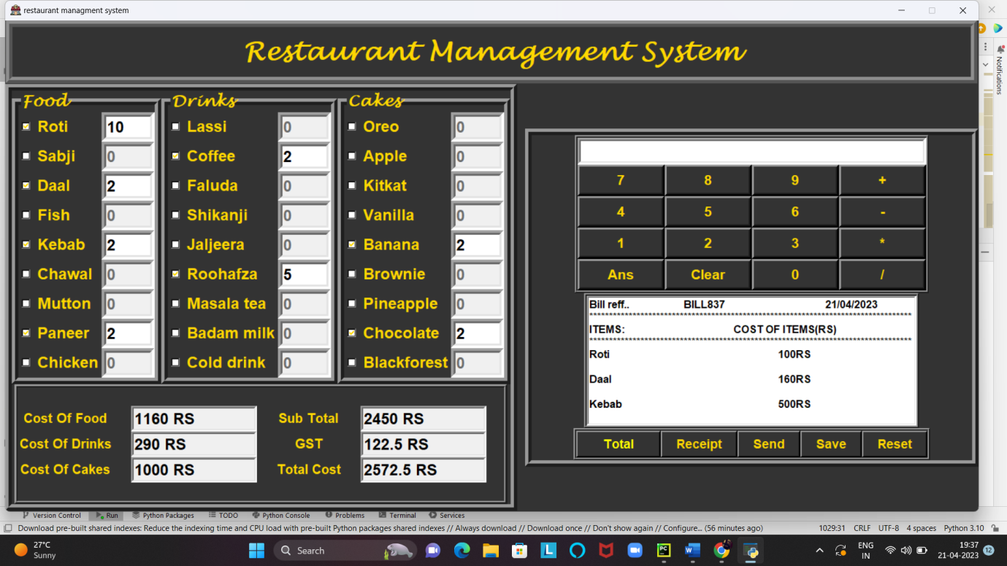

**Then we send the bill to email:-**

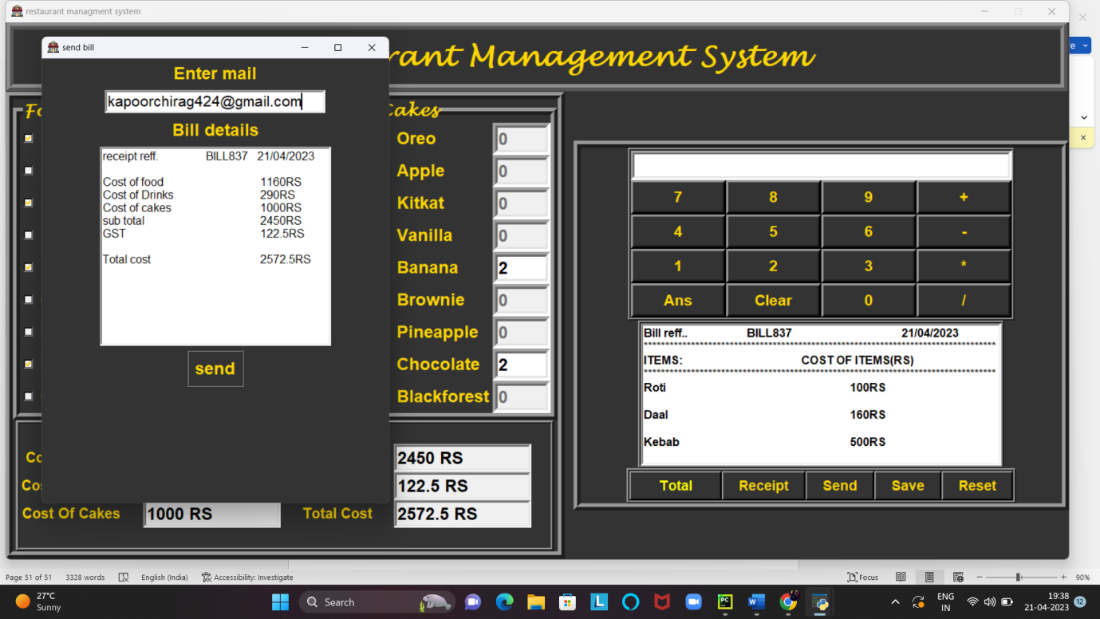

**Got the bill on email:-**

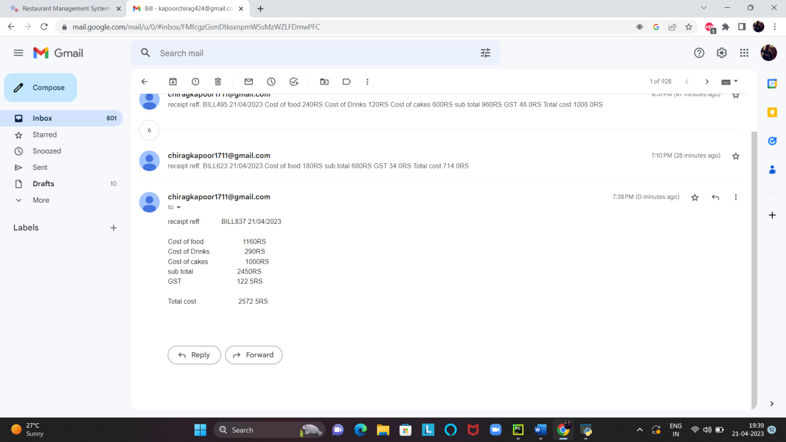**Conclusion:-**

This**Restaurant Management System Project in Python with Source Code** is the way to enhance and broaden our competencies and logic ideas which is essential in training the python

Also this **Restaurant Management System** is a easy GUI primarily based application which is very smooth to recognize and use. It makes use of Tkinter module for the GUI.

**Thank you**